**A PROJECT REPORT ON**

# “E-COMMERCE RECOMMENDATION SYSTEM”

Submitted in the partial fulfillment of the requirement for the award of the Degree of

# BACHELOR OF COMPUTER APPLICATIONS



**BENGALURU NORTH UNIVERSITY**

**Submitted by**

**JEEVAN SAJI**

**U19ON22S0047**

#### 2022-2025

**Under the Guidance of**

**Prof. Subhani Shaik**

**DEPARTMENT OF COMPUTER APPLICATIONS**



### HKBK DEGREE COLLEGE

### 22/1, Opp. Manyata Tech Park Govindapura,

### Nagawara, Bengaluru – 560045

#### ACADEMIC YEAR: 2024-2025





**CERTIFICATE**

This is to certify that the project entitled on **"E-COMMERCE RECOMMENDATION SYSTEM”,** is a bonafied work done by **JEEVAN SAJI** bearing Registration Number: **U190N22S0047**, in a partial fulfillment for the award of **Bachelor of Computer Applications** of **Bengaluru North University**, during the academic year **2022-2025.**

The report has not been submitted earlier either to this University / Institution for the fulfilment of the requirement of a course of study.

Signature of the Guide Head of Department

Prof. Subhani Shaik Prof. Subhani Shaik

Department of Computer Applications Department of Computer Applications

Signature of the Principal

Dr. Harish S B,

Principal

Examiners Valued By

1.

2.



### CERTIFICATE

This is to certify that **JEEVAN SAJI** (U19ON22S0047), Batch 2024-2025 has done the project **“E-COMMERCE RECOMMENDATION SYSTEM”** under the guidance and supervision of Prof. **Subhani Shaik, Department of Computer Applications,** which is in the partial fulfillment of the requirement for the award of Bachelor of Computer Applications, Bengaluru North University, during the academic year **2022-2025.**

Place: Bengaluru

Date:

## **CERTIFIED BY-**

Prof. Subhani Shaik

Department of Computer Applications

**STUDENT DECLARATION**

I, hereby declare that his report entitled **“E-COMMERCE RECOMMENDATION SYSTEM “is** based on an original work of independent research, carried out by me in partial fulfillment of **Bachelor of Computer Applications** Degree Course under **Bengaluru North University** of **HKBK Degree College** under the guidance of **Prof. Subhani Shaik.**

I also declare that this project is the outcome of my own efforts and that it has not been submitted to any other university or Institute for the award of any other degree or Diploma or Certificate in Bengaluru North University or any other universities.

**Name: JEEVAN SAJI Place: Bengaluru**

**Reg No: U19ON22S0047 Date:**

**ACKNOWLEDGMENTS**

I would like to express my heartfelt gratitude to all those who guided me in successfully completing this project. I am especially thankful to **Dr. Harish S.B.,** Principal, and **Prof. Subhani Shaik,** Head of the Department of Computer Applications, for their invaluable advice and encouragement throughout this endeavor.

My sincere thanks go to my faculty guide, **Prof. Subhani Shaik**, Department of Computer Applications, for her unwavering support and excellent guidance during the research process. Her enthusiasm and encouragement were instrumental in helping me complete this project.

I also wish to extend my appreciation to all the faculty members in the Department of Computer Applications for their continuous support and assistance throughout my research.

Finally, I would like to express my deepest gratitude to my family and friends for their moral support and encouragement, which motivated me throughout this journey.

**JEEVAN SAJI  
U19ON22S0047**

**TABLE OF CONTENT**

|  |  |  |
| --- | --- | --- |
| S.NO. | DESCRIPTION | PAGE NO. |
| 1 | INTRODUCTION | 01 |
| 2 | SYSTEM ANALYSIS | 06 |
| 3 | LITERATURE SURVEY | 12 |
| 4 | REQUIREMENT ANALYSIS | 17 |
| 5 | DATA FLOW DIAGRAM | 22 |
| 6 | ER-DIAGRAM | 26 |
| 7 | SYSTEM DESIGN | 27 |
| 8 | SYSTEM IMPLEMENTATION | 30 |
| 9 | CODING | 34 |
| 10 | SNAPSHOTS | 55 |
| 11 | SYSTEM TESTING | 73 |
| 12 | CONCLUSION | 76 |
| 13 | FUTURE ENHANCMENT | 78 |
| 14 | BIBLIOGRAPHY | 80 |

**INTRODUCTION**

**1.1 Overview**

In the digital era, e-commerce has rapidly transformed the way people shop, offering an unprecedented level of convenience and access to a wide array of products. As more users engage with online shopping platforms, the volume of data generated through clicks, purchases, ratings, and reviews grows exponentially. Harnessing this data to enhance user experience has become crucial for maintaining competitiveness and customer loyalty in the market.

One of the most effective ways to leverage this data is through **Recommendation Systems**, which aim to predict user preferences and suggest items they are likely to engage with or purchase. These systems play a significant role in increasing user satisfaction, retention, and ultimately, revenue generation for online platforms.

However, traditional recommendation techniques such as popularity-based or rule-based systems often fall short in offering truly **personalized** suggestions. These methods do not take into account the unique preferences and behaviors of individual users, leading to irrelevant recommendations and a suboptimal user experience.

This project focuses on developing a **Personalized E-Commerce Recommendation System** that utilizes advanced collaborative filtering techniques—**Singular Value Decomposition (SVD)** and **Neural Collaborative Filtering (NCF)**—to deliver tailored recommendations. The goal is to create a system that adapts to user preferences by learning from past interactions, thereby offering a more relevant and engaging shopping experience.

**1.2 Problem Statement**

The vast and diverse nature of product catalogues in modern e-commerce platforms creates a significant challenge for users: information overload. With hundreds or thousands of choices across categories, users often struggle to discover products that align with their tastes or needs.

Traditional filtering methods—such as filtering based on product categories, ratings, or price—are not sufficient to effectively narrow down choices. While some platforms employ collaborative filtering, many still lack deep personalization and fail to incorporate complex user behaviour.

This project addresses the limitations of conventional recommendation systems by implementing both Matrix Factorization (SVD) and Neural Network-based models (NCF) to generate personalized recommendations. The result is a dynamic, data-driven system that learns from users’ historical data to improve future interactions.

**1.3 Objectives**

The primary objectives of this project are:

* To develop a robust and scalable recommendation system that leverages collaborative filtering techniques such as SVD and NCF.
* To compare and evaluate the performance of traditional and deep learning-based models using standard metrics like RMSE, MAE, and Precision@K.
* To design an interactive and user-friendly front-end using Streamlit, which will showcase personalized recommendations in real-time.
* To integrate a MySQL database backend for managing user-product interaction data, ensuring data persistence and relational structure.
* (Optional) To use Power BI for enhanced data visualization and presentation of analytical results.

**1.4 Scope of the Project**

This project is focused solely on the development of a **personalized recommendation engine** for an e-commerce scenario. While it simulates a real-world recommendation use case, the scope does **not** extend to building a full-fledged e-commerce platform (with cart, payments, or order management).

The scope includes:

* Data collection and preprocessing
* Model training using collaborative filtering algorithms
* Comparative analysis of SVD vs NCF
* Integration with MySQL for backend data storage
* Frontend development using Streamlit for live recommendations
* Evaluation using standard metrics
* Documentation and visualization of results

By maintaining this well-defined scope, the project remains focused on its core goal: building and demonstrating the effectiveness of personalized recommendations.

**1.5 Relevance and Significance**

Recommendation systems are not just an enhancement—they are a necessity in today’s e-commerce platforms. Major players like Amazon, Netflix, and Flipkart have demonstrated how powerful recommendations can drive user engagement, increase conversion rates, and personalize the customer journey.

This project not only demonstrates the **technical implementation** of recommendation models but also emphasizes the importance of **usability**, **interpretability**, and **scalability**. By integrating both traditional and neural techniques, the system provides a comprehensive learning and experimental ground for academic and industry applications.

Furthermore, the project bridges the gap between academic knowledge and real-world applications by combining **machine learning**, **database integration**, **web application development**, and **data visualization** into a cohesive system.

**1.6 Technology Stack**

The project makes use of modern tools and libraries that are widely used in the tech industry:

|  |  |
| --- | --- |
| Technology | Purpose |
| Python | Core programming language for data handling and modeling |
| Pandas, NumPy | Data manipulation and numerical computing |
| Scikit-learn, Surprise | Implementation of SVD, evaluation metrics |
| TensorFlow/Keras | Development of NCF (Neural Collaborative Filtering) models |
| MySQL | Relational database to store and retrieve user-item interaction data |
| Streamlit | Lightweight web framework to build the front-end |
| |  | | --- | | Matplotlib, Seaborn |  |  | | --- | |  | | Visualization of results and comparisons |

This stack provides the flexibility, power, and performance needed for implementing and showcasing a real-world data-driven system.

**SYSTEM ANALYSIS**

**2.1 Introduction**

System analysis involves understanding and specifying in detail what the system should do. In the context of this project, system analysis is used to assess the goals of building a personalized recommendation system for an e-commerce scenario, define its requirements, and ensure its design will meet these needs efficiently and accurately.

This chapter explores the feasibility of the system, the system requirements (both functional and non-functional), and the proposed architecture, giving a clear and structured view of how the project will be implemented.

**2.2 Existing System**

Most traditional e-commerce platforms employ basic recommendation mechanisms like:

* Popularity-based Recommendations (e.g., top-selling items),
* Content-based Filtering (e.g., items similar to those previously purchased),
* Basic Collaborative Filtering, often user-based or item-based.

These systems have several limitations:

* Lack of personalization.
* Scalability issues with large datasets.
* Poor adaptability to sparse user-item interactions.
* Inability to understand latent user-item relationships

**2.3 Proposed System**

The proposed system aims to enhance recommendation quality by:

* Implementing Collaborative Filtering using SVD (Singular Value Decomposition).
* Applying Neural Collaborative Filtering (NCF) for deep learning-based personalization.
* Providing a web-based UI using Streamlit for easy interaction.
* Integrating a MySQL database to manage data flow efficiently.
* (Optional) Enhancing data insights with Power BI dashboards.

This approach provides more relevant, accurate, and personalized product suggestions by learning patterns in user behaviour and preferences.

**2.4 Feasibility Study**

A feasibility study helps to evaluate the practicality of the system.

2.4.1 Technical Feasibility

* Python libraries (Surprise, TensorFlow, Pandas) are open-source and widely supported.
* Streamlit and MySQL integration is straightforward.
* SVD and NCF algorithms can handle sparse and large datasets with acceptable performance.

2.4.2 Operational Feasibility

* The system is intuitive for users to interact with.
* Minimal training is required to operate the interface.
* Clear system outputs (recommendations) enhance usability.

2.4.3 Economic Feasibility

* No licensing costs due to use of open-source tools.
* Development can be done on a personal computer or cloud VM.
* Optional cloud or server deployment can scale the system for real users.

**2.5 Functional Requirements**

|  |  |
| --- | --- |
| **ID** | **REQUIREMENT DESCRIPTION** |
| FR1 | The system should accept user-item rating data input. |
| FR2 | It should train an SVD model using collaborative filtering. |
| FR3 | It should train a neural model using NCF for recommendation. |
| FR4 | The system must return Top-N personalized product recommendations. |
| FR5 | The UI must display recommended items to users dynamically. |
| FR6 | It should allow performance evaluation using metrics like RMSE, MAE, Precision@K. |
| FR7 | The backend must store and retrieve data using MySQL. |

**2.6 Non-Functional Requirements**

|  |  |
| --- | --- |
| **ID** | **REQUIREMENT DESCRIPTION** |
| NFR1 | |  | | --- | |  |  |  | | --- | | The system must respond within 2 seconds for typical recommendation queries. | |
| NFR2 | The UI must be responsive and user-friendly. |
| NFR3 | |  | | --- | |  |  |  | | --- | | The model training process should support scalability. | |
| NFR4 | System should be modular for future upgrades or API integrations. |

**2.7 System Architecture**

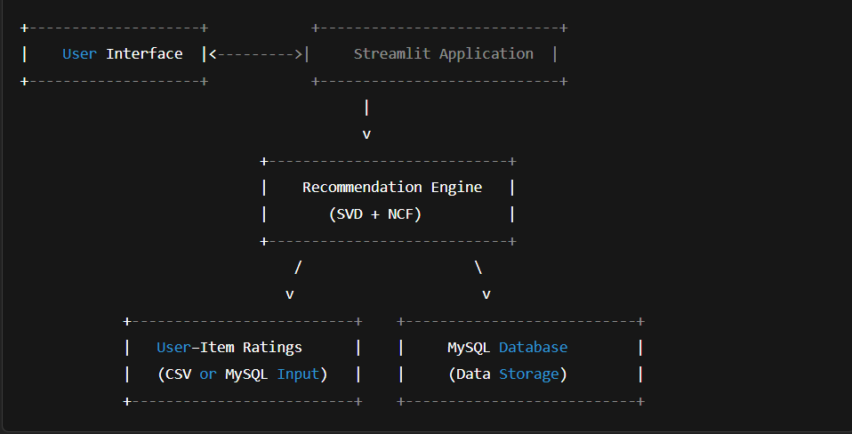

**2.8 Data Flow Diagram (DFD)**

**Level 0: Context Level DFD**

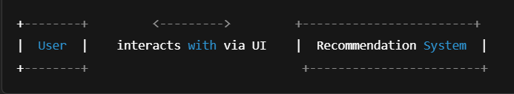

**Level 1: DFD**

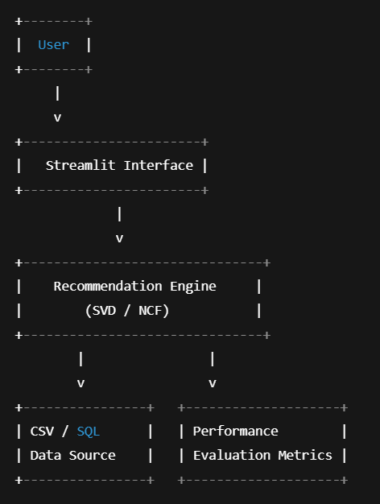

**2.9 SWOT Analysis**

|  |  |
| --- | --- |
| **Strengths** | **Weaknesses** |
| **Personalized recommendations** | **Cold-start problem for new users** |
| **Scalable design with Streamlit** | **Requires enough data for NCF** |
| **Easy to use interface** | **Initial training time for models** |

**2.10 OPPORTUNITY/THREATS**

|  |  |
| --- | --- |
| **Opportunities** | **Threats** |
| **Extendable to real-world usage** | **Data privacy and security risks** |
| **Can be deployed on cloud** | **Rapidly changing tech landscape** |

**LITERATURE SURVEY**

**3.1 Introduction**

A literature survey is essential for understanding the current landscape of research and development in a specific domain. It provides insights into existing methodologies, highlights their limitations, and identifies gaps that new research can address. In the context of recommendation systems, numerous models and algorithms have evolved to improve personalization, scalability, and user satisfaction. This chapter explores various academic and industrial approaches to collaborative filtering, hybrid models, and deep learning-based recommenders.

3.2 Review of Existing Literature

**1. Collaborative Filtering Techniques**

AUTHOR: JS BREESE, D.HECKERMAN AND C.KADIE (1998)

TITLE: EMPIRICAL ANALYSIS OF PREDICTIVE ALGORITHMS FOR COLLOBORATIVE FILTERING

**Summary:**  
This foundational paper compares user-based and item-based collaborative filtering. It concludes that item-based filtering is more scalable and stable, especially for large-scale e-commerce environments. However, both methods suffer from sparsity and cold-start issues.

**2. Matrix Factorization (SVD)**

**AUTHOR: YEHUDA KOREN, ROBERT BELL AND CHRIS VOLINSKY (2009)**

**TITLE: MATRIX FACTORIZATION FOR RECOMMENDER SYSTEM**

**Summary:**Introduced latent factor models, particularly SVD, which decompose the user-item matrix into user and item vectors. These techniques proved effective in the Netflix Prize challenge and remain a strong baseline for recommender systems. However, SVD requires retraining when new data arrives, which may be inefficient in real-time systems.

**3. Deep Learning for Recommendations**

**Author: Xiangnan He et al. (2017)**

**Title: Neural Collaborative Filtering**

**Summary:**  
This paper proposed Neural Collaborative Filtering (NCF), combining generalized matrix factorization with deep neural networks to model complex non-linear user-item interactions. NCF outperforms traditional CF in terms of prediction accuracy and recommendation relevance, especially for sparse datasets.

**4. Hybrid Recommendation Systems**

**Author: Robin Burke (2002)**

**Title: Hybrid Recommender Systems: Survey and Experiments**

**Summary:**This paper explores combining multiple recommendation strategies (e.g., content-based + CF) to enhance recommendation quality and overcome individual limitations. Hybrid systems often outperform single-method models but are more complex to design and maintain.

**5. Real-time Recommendation Systems**

**Author: Badrul Sarwar et al. (2001)**

**Title: Item-based Collaborative Filtering Recommendation Algorithms**

**Summary:  
Focused on the scalability of recommendation systems for real-time applications. The paper discusses pre-computing item similarities to reduce computational load and latency, an approach later used in many e-commerce platforms like Amazon.**

**6. Recommendation System Evaluation Metrics**

**Author: Shani and Gunawardana (2009)**

**Title: Evaluating Recommendation Systems**

**Summary:  
This work introduces and analyzes several evaluation metrics such as RMSE, MAE, Precision@K, Recall, and NDCG. These metrics are critical for understanding how well a recommendation model performs in various user scenarios.**

**3.3 Summary Table of Reviewed Papers**

|  |  |  |  |
| --- | --- | --- | --- |
| **Author(s)** | **Title** | **Technique Used** | **Key Contribution** |
| **Breese et al. (1998)** | |  | | --- | | **Empirical Analysis of CF** |  |  | | --- | |  | | |  | | --- | | **User/Item-based CF** |  |  | | --- | |  | | |  | | --- | | **Baseline comparison of CF approaches** |  |  | | --- | |  | |
| |  | | --- | | **Koren et al. (2009)** |  |  | | --- | |  | | |  | | --- | | **Matrix Factorization Techniques** |  |  | | --- | |  | | **SVD** | |  | | --- | | **Latent factor models for personalization** |  |  | | --- | |  | |
| |  | | --- | | **He et al. (2017)** |  |  | | --- | |  | | |  | | --- | | **Neural Collaborative Filtering** |  |  | | --- | |  | | |  | | --- | | **Deep Learning + CF** |  |  | | --- | |  | | |  | | --- | | **Captures complex non-linear patterns** |  |  | | --- | |  | |
| |  | | --- | | **Burke (2002)** |  |  | | --- | |  | | |  | | --- | | **Hybrid Recommender Systems** |  |  | | --- | |  | | |  | | --- | | **Hybrid Methods** |  |  | | --- | |  | | |  | | --- | | **Combines multiple methods for accuracy** |  |  | | --- | |  | |
| |  | | --- | | **Sarwar et al. (2001)** |  |  | | --- | |  | | |  | | --- | | **Item-based CF for Real-time Systems** |  |  | | --- | |  | | |  | | --- | | **Item-based CF** |  |  | | --- | |  | | |  | | --- | | **Pre-computation for real-time performance** |  |  | | --- | |  | |
| |  | | --- | | **Shani & Gunawardana** |  |  | | --- | |  | | |  | | --- | | **Evaluating Recommendation Systems** |  |  | | --- | |  | | |  | | --- | | **Evaluation Metrics** |  |  | | --- | |  | | **Standardizes performance assessment** |

**3.4 Gap Analysis**

While traditional collaborative filtering techniques are useful, they suffer from several limitations:

* Cold Start Problem: Difficulty recommending items for new users or products with little data.
* Sparsity: Most real-world user-item matrices are sparse, leading to reduced accuracy.
* Linear Modeling: Techniques like SVD assume linear relationships between users and items.
* Lack of Real-time Adaptability: Many models are batch-trained and do not adapt in real time.

To address these gaps, our project introduces Neural Collaborative Filtering (NCF), which uses deep learning to capture non-linear patterns and improve accuracy, especially in sparse and dynamic datasets.

**3.5 Conclusion**

The literature survey reveals that while conventional collaborative filtering and matrix factorization models offer solid baselines, newer models like NCF provide better personalization. Integrating these methods within a user-friendly UI and evaluating them using multiple metrics will result in a well-rounded, practical recommendation system suited for real-world e-commerce platforms.

**REQUIREMENT ANALYSIS**

**Project Title: Personalized E-Commerce Recommendation System Using Collaborative Filtering**

**3.1 Introduction**

Requirement analysis is a critical step in the software development life cycle. It involves gathering, analysing, and documenting the functional and non-functional requirements of the system. This chapter outlines the expected functionalities, user expectations, and technical needs for developing the personalized recommendation system.

**3.2 Purpose of the System**

The primary purpose of this system is to provide personalized product recommendations to users based on their historical interactions using collaborative filtering methods such as Singular Value Decomposition (SVD) and Neural Collaborative Filtering (NCF). The system also aims to evaluate the performance of the models and visualize the outcomes via an intuitive user interface.

**3.3 System Overview**

The recommendation system has three key components:

1. **Backend Engine:** Uses SVD and NCF models to generate predictions.
2. **Frontend Interface:** Built using Streamlit to interact with users.
3. **Database Layer:** MySQL stores user and product interaction data.

**3.4 Functional Requirements**

|  |  |  |  |  |  |
| --- | --- | --- | --- | --- | --- |
| |  | | --- | | **ID** |  |  | | --- | |  | | | **Requirement Description** | | --- |  |  | | --- | |  | |
| |  | | --- | | FR1 |  |  | | --- | |  | | |  | | --- | | Users can view recommended products based on their preferences. |  |  | | --- | |  | |
| FR2 | |  | | --- | | Admin/Developer can upload user-item interaction data. |  |  | | --- | |  | |
| FR3 | |  | | --- | | The system should train and evaluate SVD and NCF models. |  |  | | --- | |  | |
| FR4 | |  | | --- | | The UI must show personalized outputs using Streamlit. |  |  | | --- | |  | |
| FR5 | |  | | --- | | Display evaluation metrics (RMSE, MAE, Precision@K) for each model. |  |  | | --- | |  | |
| FR6 | Allow dynamic filtering of recommended products. |

**3.5 Non-Functional Requirements**

|  |  |  |  |  |  |
| --- | --- | --- | --- | --- | --- |
| |  | | --- | | **ID** |  |  | | --- | |  | | | **Requirement Description** | | --- |  |  | | --- | |  | |
| **NFR1** | |  | | --- | | **The system must be responsive and user-friendly.** |  |  | | --- | |  | |
| **NFR2** | |  | | --- | | **It should process and generate recommendations within 5 seconds.** |  |  | | --- | |  | |
| **NFR3** | |  | | --- | | **The system should be scalable for larger datasets.** |  |  | | --- | |  | |
| **NFR4** | |  | | --- | | **Data privacy should be ensured (no leakage of user identity).** |  |  | | --- | |  | |
| **NFR5** | **The UI should support both desktop and tablet views.** |

**3.6 User Requirements**

* Users expect accurate and relevant product recommendations.
* Admin expects easy management of data uploads and model retraining.
* Stakeholders require a comparative evaluation of models.

**3.7 SYSTEM REQUIREMENTS**

**3.7.1 Hardware Requirements**

|  |  |
| --- | --- |
| Component | Specification |
| Processor | |  | | --- | | Intel i5 or higher |  |  | | --- | |  | |
| RAM | |  | | --- | | Minimum 8 GB |  |  | | --- | |  | |
| |  | | --- | | Hard Disk |  |  | | --- | |  | | |  | | --- | | 100 GB free space |  |  | | --- | |  | |
| |  | | --- | | Graphics |  |  | | --- | |  | | **Optional (for deep learning acceleration)** |

**3.7.2 Software Requirements**

|  |  |
| --- | --- |
| Component | Specification |
| OS | |  | | --- | | Windows 10 / Linux / macOS |  |  | | --- | |  | |
| Language | |  | | --- | | Python 3.8+ |  |  | | --- | |  | |
| Libraries | |  | | --- | | Pandas, NumPy, Scikit-learn, Surprise, TensorFlow, Keras, Streamlit |  |  | | --- | |  | |
| Database | |  | | --- | | MySQL 8.0 |  |  | | --- | |  | |
| Others | Jupyter Notebook |

**3.8 Constraints**

* Limited dataset size due to time and hardware constraints.
* Model accuracy may be affected by sparsity in user-item interaction data.
* NCF model training requires GPU for faster performance, which may not be available.

**3.9 Assumptions**

* User interactions (ratings, views, purchases) are already collected or simulated.
* The dataset format is consistent and well-structured (CSV or SQL).
* Users have access to a basic browser to interact with the Streamlit UI.

**3.10 Conclusion**

This chapter defined the foundational requirements of the personalized recommendation system. With both functional and non-functional aspects outlined, the development process can proceed with clarity and purpose. These requirements will serve as the benchmark for design, implementation, and validation phases.

**DATA FLOW DIAGRAM**

**4.1 Introduction**

A Data Flow Diagram (DFD) is a graphical tool used to visualize the flow of data through a system. It illustrates how data is processed, stored, and transferred between different components. In the context of a personalized recommendation system, the DFD helps to understand how user data flows through the recommendation engine, models, and user interface.

We present both Level 0 (Context Diagram) and Level 1 (Detailed View) DFDs in this chapter.

**4.2 Level 0 DFD – Context Level**

The **Level 0 DFD** gives an overall view of the system as a single process with external entities:

**Entities:**

* **User**: Interacts with the system to receive recommendations.
* **Admin**: Uploads datasets, monitors model training.
* **Database**: Stores user-item interactions, product data.

**Process:**

* **Recommendation Engine**: The core process that takes user input, queries the database, processes the data through SVD/NCF models, and returns recommendations.

**Level 0 DFD Diagram (Textual Representation):**

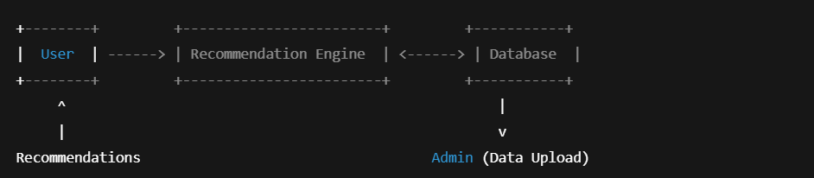

**4.3 Level 1 DFD – Functional Decomposition**

The Level 1 DFD breaks the recommendation engine into multiple subprocesses for clarity:

Processes:

1. 1.0 Load User Data
2. 2.0 Train Recommendation Model (SVD / NCF)
3. 3.0 Generate Recommendations
4. 4.0 Display in Streamlit UI
5. 5.0 Evaluate Model (RMSE, MAE, Precision@K)

Level 1 DFD Diagram (Textual Representation):

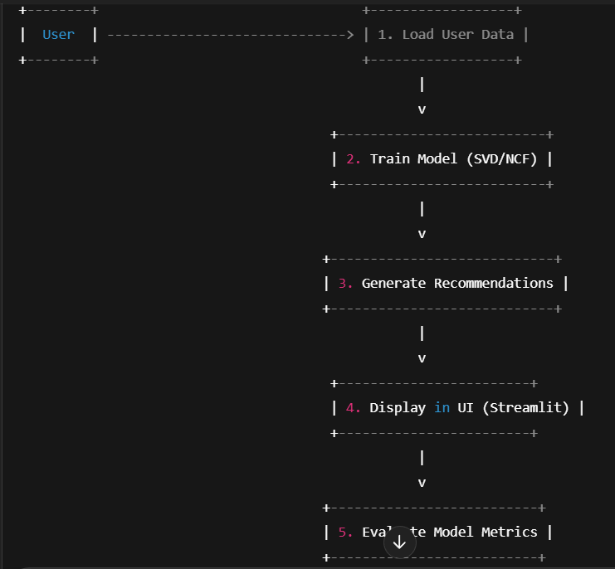

**4.4 Explanation of Components**

|  |  |  |  |
| --- | --- | --- | --- |
| |  | | --- | | **Component** |  |  | | --- | |  | | Description |
| User | |  | | --- | | End user who receives personalized product suggestions. |  |  | | --- | |  | |
| Admin | |  | | --- | | Manages data uploads, initiates model training. |  |  | | --- | |  | |
| Database | |  | | --- | | Stores user-item interaction data, product details. |  |  | | --- | |  | |
| |  | | --- | | Train Model |  |  | | --- | |  | | |  | | --- | | Trains models using collaborative filtering (SVD) and deep learning (NCF). |  |  | | --- | |  | |
| |  | | --- | | **Recommendation Engine** |  |  | | --- | |  | | |  | | --- | | Predicts top-N recommendations for users. | |  |  |  | | --- | |  | |
| |  | | --- | | **Streamlit UI** |  |  | | --- | |  | | |  | | --- | | Frontend interface to display output in a simple and interactive way. |  |  | | --- | |  | |

**4.5 Conclusion**

The Data Flow Diagrams help visualize how data moves within the system from input to output. These diagrams guide the logical structure of the software development and ensure clarity between developers, users, and stakeholders**.**

**ER DIAGRAM**

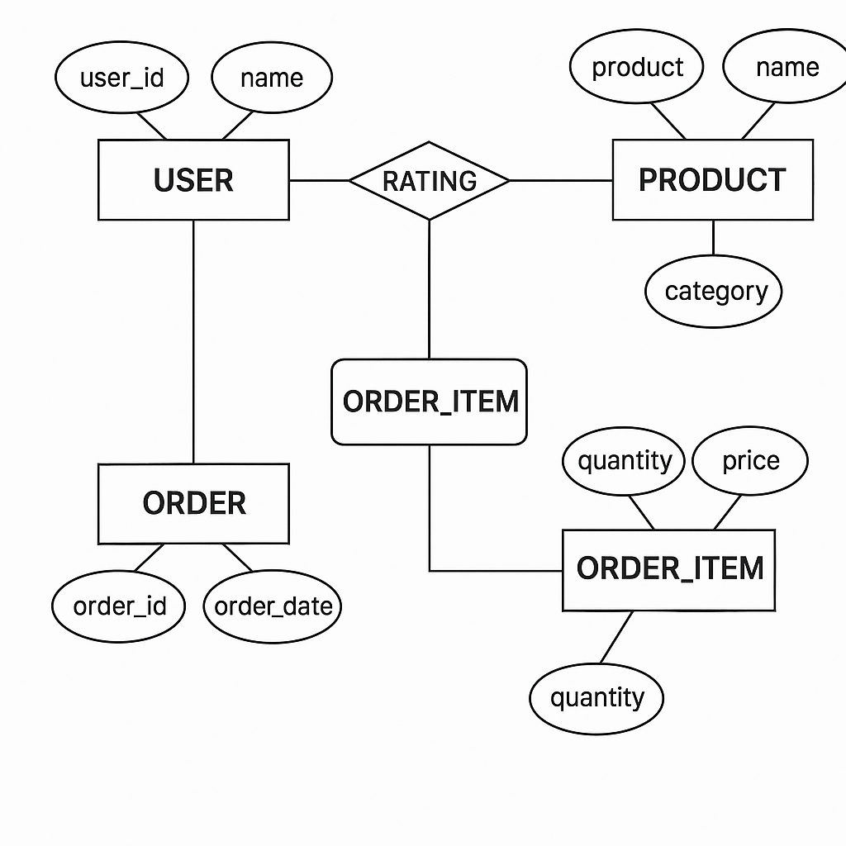

**SYSTEM DESIGN**

**5.1 Introduction**

System design is the process of defining the architecture, components, modules, interfaces, and data flow of a system to satisfy specified requirements. In this chapter, we present the high-level and detailed design of the personalized recommendation system using SVD and Neural Collaborative Filtering (NCF), integrated with a MySQL database and a Streamlit-based user interface.

**5.2 Design Objectives**

* To ensure modularity and scalability of the system.
* To maintain separation between data processing, model training, and user interface.
* To support easy evaluation and model comparison.
* To facilitate future extension with additional algorithms or data types.

**5.3 System Architecture**

The architecture is designed with three primary layers:

**1. Data Layer**

* Contains raw and processed datasets.
* MySQL is used to store user-item interactions and product information.

**2. Logic Layer (Recommendation Engine)**

* Implements SVD and NCF algorithms for collaborative filtering.
* Handles model training, prediction generation, and evaluation.

**3. Presentation Layer (UI)**

* Streamlit-based interface for users to view recommendations.
* Admin interface for dataset upload and model comparison.

**System Architecture Diagram (Textual Layout)**

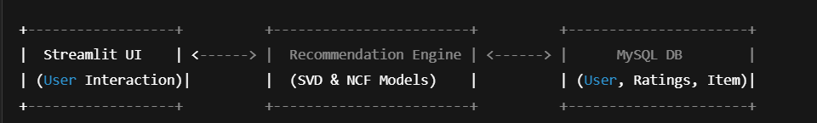

**5.4 Component Design**

**5.4.1 User Module**

* Inputs: User ID or login
* Function: Triggers the recommendation generation for the user
* Output: List of top-N recommended products

**5.4.2 Admin Module**

* Inputs: Dataset CSV or direct DB entries
* Function: Upload, train models, compare performance
* Output: Evaluation metrics and model reports

**5.4.3 Model Training Module**

* Inputs: User-item interaction matrix
* Techniques:
  + **SVD (Surprise Library)**
  + **NCF (TensorFlow/Keras)**
  + Output: Trained models saved locally or in memory

**5.4.4 Recommendation Generation Module**

* Function: Takes a user ID and returns the top-N predicted ratings
* Algorithm: Model.predict() + sorting top-N items

**5.4.5 Evaluation Module**

* Metrics: RMSE, MAE, Precision@K
* Output: Metric values and visualizations (via Streamlit )

**5.5 Data Design**

**5.5.1 Tables**

* users(user_id, name, age, location)
* items(item_id, name, category)
* ratings(user_id, item_id, rating)

**5.5.2 Sample Schema**

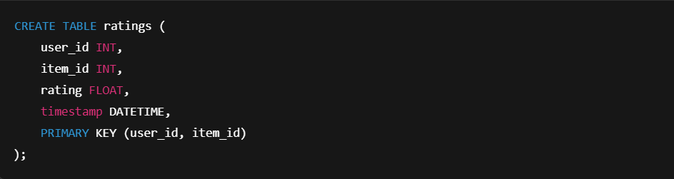

**5.6 Streamlit UI Design**

**User Interface Features**

* Select user ID from dropdown
* Click to generate recommendations
* Display evaluation metrics in sidebar
* Optional: Charts for rating distribution or top-N popularity

**5.7 Security Design**

* User data is anonymized (user IDs only).
* No personal identifiers are displayed.
* Admin upload access is restricted and protected.
* Database connections are handled using environment variables or secure configs.

**5.8 Design Principles Followed**

* **Modularity**: Each component (training, prediction, UI) is in a separate module.
* **Scalability**: Designed to handle additional data and models.
* **Reusability**: Common functions like evaluation are reused across models.
* **Maintainability**: Clear folder structure and documentation for future improvements.

**5.9 Conclusion**

The system design lays a solid foundation for the implementation of the personalized e-commerce recommendation system. By separating concerns across layers and ensuring modularity, the system is both scalable and easy to maintain.

**SYSTEM IMPLEMENTATION**

**6.1 Introduction**

System implementation involves converting the theoretical design into a working software application. This phase focuses on coding, integrating various modules, and ensuring the system operates according to the intended functionality. In this project, we have implemented both SVD-based Collaborative Filtering and Neural Collaborative Filtering (NCF) for generating personalized product recommendations in an e-commerce setting.

**6.2 Development Environment**

|  |  |  |  |
| --- | --- | --- | --- |
| Component | | **Tool/Technology** | | --- |  |  | | --- | |  | |
| |  | | --- | | Programming Language |  |  | | --- | |  | | |  | | --- | | Python 3.11+ |  |  | | --- | |  | |
| |  | | --- | | UI Framework |  |  | | --- | |  | | |  | | --- | | Streamlit |  |  | | --- | |  | |
| Database | MySQL |
| |  | | --- | | ML Libraries |  |  | | --- | |  | | |  | | --- | | Surprise, TensorFlow, Keras |  |  | | --- | |  | |
| |  | | --- | | Data Handling |  |  | | --- | |  | | |  | | --- | | Pandas, NumPy |  |  | | --- | |  | |
| |  | | --- | | Visualization |  |  | | --- | |  | | |  | | --- | | Matplotlib, Seaborn |  |  | | --- | |  | |
| OS | |  | | --- | | Windows/Linux |  |  | | --- | |  | |
| IDE | VS Code / Jupyter Notebook |

**6.3 Implementation Modules**

**6.3.1 Data Preprocessing**

* Load user-item interaction dataset.
* Handle missing values and normalize ratings.
* Split dataset into train and test sets for evaluation.

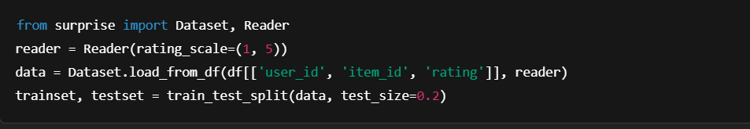

**6.3.2 SVD-Based Collaborative Filtering**

Implemented using the **Surprise** library:

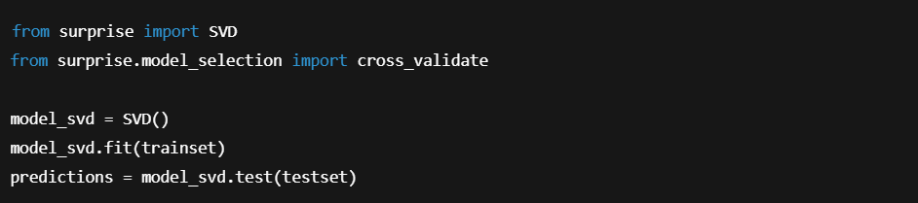

**6.3.3 Neural Collaborative Filtering (NCF)**

Implemented using **Keras and TensorFlow**:

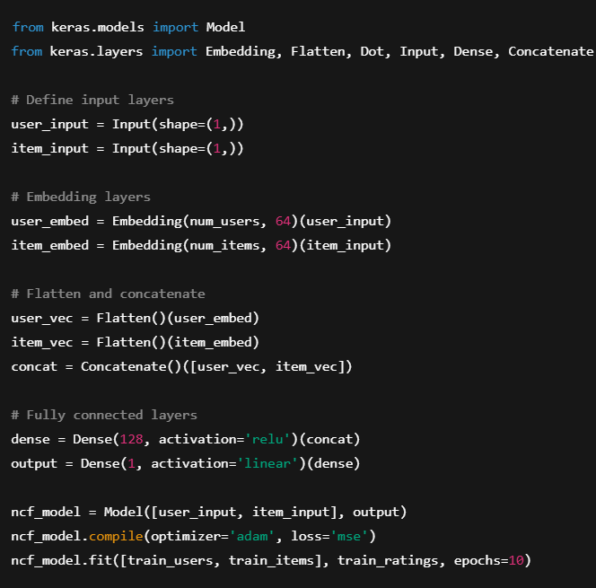

**6.3.4 Recommendation Generation**

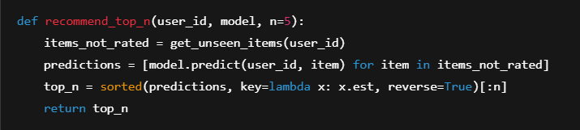

**6.3.5 Model Evaluation**

Used metrics:

* RMSE (Root Mean Squared Error)
* MAE (Mean Absolute Error)
* Precision@K

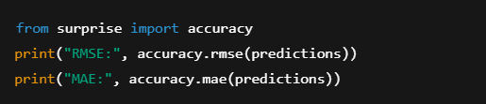

**6.3.6 Streamlit UI Integration**

Streamlit provides a clean frontend for user interaction:

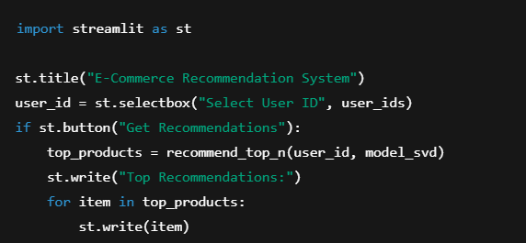

**6.3.7 MySQL Integration**

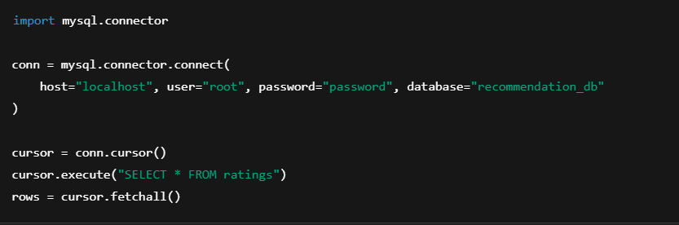

**6.4 Screenshots of the Application**

Include the following:

* Model training console logs
* Streamlit UI homepage
* Output screen showing top-N recommendations
* Evaluation metrics display
* MySQL DB table views

(Let me know if you want help generating or editing these screenshots.)

**6.5 Challenges Faced**

* Ensuring model compatibility with sparse data.
* Balancing between accuracy and performance (SVD faster, NCF more accurate).
* Integrating MySQL data with real-time Streamlit recommendations.
* Optimizing NCF model parameters to prevent overfitting.

**6.6 Conclusion**

The system was successfully implemented using both traditional and deep learning-based collaborative filtering techniques. The integration of Streamlit with a backend database and recommendation logic provides a robust and user-friendly recommendation platform.

**CODING**

**[IMPORT FUNCTIONS ]**

**Basic Setup**

import warnings

warnings.filterwarnings('ignore')

**Purpose**: Suppresses warning messages in output. Useful to keep notebooks clean while testing or deploying

**Core Python Libraries**

import numpy as np

import pandas as pd

* numpy: Supports efficient numerical computations and matrix operations (e.g., SVD).
* pandas: Used for reading, writing, and manipulating data in tabular form (DataFrames).

**MySQL Connection**

import mysql.connector

Used to connect your Python code to a **MySQL** database, allowing SQL queries to fetch user/item/rating data.

**Data Visualization**

import matplotlib.pyplot as plt

import seaborn as sns

sns.set(style='whitegrid')

* matplotlib.pyplot: Core plotting library for line charts, bar plots, etc.
* seaborn: Higher-level visualization library built on top of matplotlib. Used for prettier, easier visualizations.
* sns.set(style='whitegrid'): Applies a clean style to all plots (white background with grid lines).

**Matrix Operations**

from scipy.sparse import csr_matrix

from scipy.sparse.linalg import svds

* csr_matrix: Creates **sparse matrices**, which are memory-efficient when dealing with large user-item matrices.
* svds: Performs **Singular Value Decomposition (SVD)** on sparse matrices for collaborative filtering.

**Machine Learning Utilities**

from sklearn.metrics.pairwise import cosine_similarity

from sklearn.model_selection import train_test_split

from sklearn.feature_extraction.text import TfidfVectorizer

from sklearn.preprocessing import LabelEncoder

from sklearn.metrics import mean_squared_error, mean_absolute_error

* cosine_similarity: Measures similarity between users or items (used in item-based/user-based filtering).
* train_test_split: Splits data into training and testing sets for model evaluation.
* TfidfVectorizer: Converts text (e.g., product descriptions) into numeric vectors for **content-based** filtering.
* LabelEncoder: Converts categorical data (e.g., user/item IDs) into numeric labels.
* mean_squared_error, mean_absolute_error: Used for evaluating prediction accuracy (regression metrics).

**Surprise Library (Recommender Systems)**

from surprise import Dataset, Reader, SVD

from surprise.model_selection import cross_validate

* Dataset, Reader: Load and prepare data for the surprise library.
* SVD: Built-in matrix factorization algorithm from Surprise for collaborative filtering.
* cross_validate: Performs k-fold cross-validation to evaluate model performance.

**Utility**

from collections import defaultdict

Provides specialized data structures like defaultdict, helpful for organizing predictions or user-item mappings.

**Deep Learning (Keras + TensorFlow)**

import tensorflow as tf

from tensorflow.keras.models import Model

from tensorflow.keras.layers import Input, Embedding, Flatten, Dense, Concatenate, Dropout

from tensorflow.keras.optimizers import Adam

from tensorflow.keras.metrics import RootMeanSquaredError

from tensorflow.keras.callbacks import EarlyStopping

Used for building **Neural Collaborative Filtering (NCF)** models:

* Input, Embedding, Dense, etc.: Define neural network architecture (users/items as embeddings).
* Adam: Optimization algorithm.
* RootMeanSquaredError: Evaluation metric for model performance.
* EarlyStopping: Stops training when performance stops improving, to prevent overfitting.

**Environment Management**

import os

from dotenv import load_dotenv

* **os: Access system environment variables.**
* **load_dotenv: Loads sensitive credentials (e.g., DB password) from .env file for security.**

**Model Persistence**

import joblib

Used to **save and load trained models or preprocessing objects** (e.g., encoders) for later use without retraining.

**MYSQL – CONNECTION CODE**

Load Environment Variables

load_dotenv()

* **Purpose**: Loads values from a .env file (such as DB credentials) into environment variables.
* Safer than hardcoding credentials.

**Connect to MySQL**

try:

conn = mysql.connector.connect(

host=os.getenv("DB_HOST", "localhost"),

user=os.getenv("DB_USER", "root"),

password=os.getenv("DB_PASS", "123456"),

database=os.getenv("DB_NAME", "ecommerce_recommendation")

)

* Tries to **establish a connection** using credentials from .env.
* Defaults are provided (localhost, root, etc.) if environment variables are missing.

print(" Connected to database.")

Confirms successful connection.

except mysql.connector.Error as err:

print(f" Database connection failed: {err}")

conn = None

df = pd.DataFrame()

raise ConnectionError("Cannot proceed without database connection.")

* Handles **connection errors** (e.g., wrong credentials, DB not running).
* Initializes an empty DataFrame and raises a ConnectionError.

Load Data from Database

if conn and conn.is_connected():

query = "SELECT user_id, prod_id, rating, timestamp FROM user_rating"

* Only runs if the database is connected.
* SQL query to extract data from the user_rating table.

df = pd.read_sql(query, conn)

Uses pandas to directly load SQL query results into a DataFrame (df).

Validate Data Columns

expected_columns = ['user_id', 'prod_id', 'rating', 'timestamp']

if not all(col in df.columns for col in expected_columns):

raise ValueError(f" Missing required columns. Found: {df.columns}")

* Checks if all required columns are present.
* Raises a ValueError if any are missing.

Drop Unused Column

df = df.drop('timestamp', axis=1)

Removes the timestamp column (not needed for recommendation calculations).

Validate Ratings

invalid_ratings = df[~df['rating'].between(1, 5)]

if not invalid_ratings.empty:

print(f" Found {len(invalid_ratings)} invalid ratings. Removing them.")

df = df[df['rating'].between(1, 5)]

* Ensures all rating values are between **1 and 5**.
* If not, prints a warning and filters them out.

Summary Message

print(f" Loaded {df.shape[0]} ratings successfully.")

Confirms successful loading and displays how many valid records are present.

Cleanup

finally:

conn.close()

Closes the database connection no matter what (success or failure).

Handle No Connection Case

else:

print(" No database connection. Initializing empty DataFrame.")

df = pd.DataFrame()

If the connection never succeeded, initialize an empty DataFrame.

Final Check

if df.empty:

raise ValueError(" No data loaded. Check database connection or query.")

**Final safety check**: If no data is loaded, raise a ValueError to prevent proceeding with invalid inputs.

**Summary**

|  |  |  |  |
| --- | --- | --- | --- |
| load_dotenv() | |  | | --- | |  |  |  | | --- | | Securely load credentials | |
| mysql.connector.connect() | Connect to MySQL DB |
| pd.read_sql() | Load ratings data |
| df['rating'].between(1, 5) | Validate rating values |
| conn.close() | Clean DB shutdown |
| Exception handling | Prevent crashes and guide debugging |

**Top-N Recommendation Function**

def recommend_top_n(user_id, n=5):

# Get the predicted ratings for the user

user_row = predicted_ratings_df.loc[user_id].sort_values(ascending=False)

# Get the products the user has already rated

already_rated = final_ratings_matrix.loc[user_id][final_ratings_matrix.loc[user_id] > 0].index

# Drop already rated products from the recommendations

recommendations = user_row.drop(index=already_rated).head(n)

return recommendations

# Example: Get top 5 product IDs for user with index 0

top5 = recommend_top_n(0)

print("🎯 Top 5 Recommendations for User 0:")

print(top5)

**Top-N (IMDb-style / Rank-Based) – Global Popularity**

# Step 1: Clean and prepare rating data

df_final['rating'] = pd.to_numeric(df_final['rating'], errors='coerce')

df_final = df_final.dropna(subset=['rating'])

# Step 2: Calculate average rating and rating count per product

average_rating = df_final.groupby('prod_id')['rating'].mean()

count_rating = df_final.groupby('prod_id')['rating'].count()

# Step 3: Combine into final_rating DataFrame

final_rating = pd.DataFrame({

'avg_rating': average_rating,

'rating_count': count_rating

})

# Step 4: Rank-Based Recommendation Function (IMDb-style)

def get_top_n_products(final_rating, n=10, min_interaction=3):

C = final_rating['avg_rating'].mean()

m = final_rating['rating_count'].quantile(0.50) # median or custom value

# Filter products with enough interactions

qualified = final_rating[final_rating['rating_count'] >= min_interaction].copy()

# IMDb Weighted Score Formula

qualified['weighted_score'] = (

(qualified['rating_count'] / (qualified['rating_count'] + m)) * qualified['avg_rating'] +

(m / (m + qualified['rating_count'])) * C

)

# Sort by weighted score

return qualified.sort_values('weighted_score', ascending=False).head(n)

# Step 5: Get Top N Globally Recommended Products

top_products = get_top_n_products(final_rating, n=10, min_interaction=3)

# Step 6: Display result

print("🏆 Top Ranked Products (Global Recommendation):\n")

print(top_products)

**Neural Collaborative Filtering (NCF)**

# Prepare data for NCF

user_ids = df_filtered['user_id'].astype('category').cat.codes

item_ids = df_filtered['prod_id'].astype('category').cat.codes

ratings = df_filtered['rating'].values

n_users = user_ids.nunique()

n_items = item_ids.nunique()

embedding_dim = 50

from sklearn.model_selection import train_test_split

X = np.array([user_ids, item_ids]).T

y = ratings

X_train, X_test, y_train, y_test = train_test_split(X, y, test_size=0.2, random_state=42)

# Build NCF model

user_input = Input(shape=(1,), name='user_input')

item_input = Input(shape=(1,), name='item_input')

user_embedding = Embedding(n_users, embedding_dim, name='user_embedding')(user_input)

item_embedding = Embedding(n_items, embedding_dim, name='item_embedding')(item_input)

user_vec = Flatten()(user_embedding)

item_vec = Flatten()(item_embedding)

concat = Concatenate()([user_vec, item_vec])

dense = Dense(128, activation='relu')(concat)

dense = Dropout(0.3)(dense)

dense = Dense(64, activation='relu')(dense)

output = Dense(1, activation='linear')(dense)

ncf_model = Model(inputs=[user_input, item_input], outputs=output)

ncf_model.compile(optimizer='adam', loss='mse', metrics=['mae'])

# Train model

history = ncf_model.fit(

[X_train[:, 0], X_train[:, 1]], y_train,

validation_data=([X_test[:, 0], X_test[:, 1]], y_test),

epochs=10,

batch_size=256,

verbose=1

)

# Plot training history

plt.figure(figsize=(10, 6))

plt.plot(history.history['loss'], label='Training Loss')

plt.plot(history.history['val_loss'], label='Validation Loss')

plt.title('NCF Model Loss')

plt.xlabel('Epoch')

plt.ylabel('Loss')

plt.legend()

plt.savefig('ncf_loss.png')

plt.close()

def get_ncf_recommendations(user_id, n=5):

if user_id not in df_filtered['user_id'].values:

return pd.DataFrame(columns=['ProductID', 'PredictedRating'])

user_code = df_filtered[df_filtered['user_id'] == user_id]['user_id'].astype('category').cat.codes.iloc[0]

all_items = df_filtered['prod_id'].astype('category').cat.categories

item_codes = df_filtered['prod_id'].astype('category').cat.codes.unique()

rated_items = df_filtered[df_filtered['user_id'] == user_id]['prod_id'].astype('category').cat.codes.values

items_to_predict = [i for i in item_codes if i not in rated_items]

user_array = np.array([user_code] * len(items_to_predict))

predictions = ncf_model.predict([user_array, np.array(items_to_predict)]).flatten()

top_indices = np.argsort(predictions)[-n:][::-1]

top_items = all_items[items_to_predict][top_indices]

top_scores = predictions[top_indices]

return pd.DataFrame({'ProductID': top_items, 'PredictedRating': top_scores})

**# Test NCF recommendations**

test_user_id = df_filtered['user_id'].iloc[0]

print(f" NCF Recommendations for user {test_user_id}:")

print(get_ncf_recommendations(test_user_id))

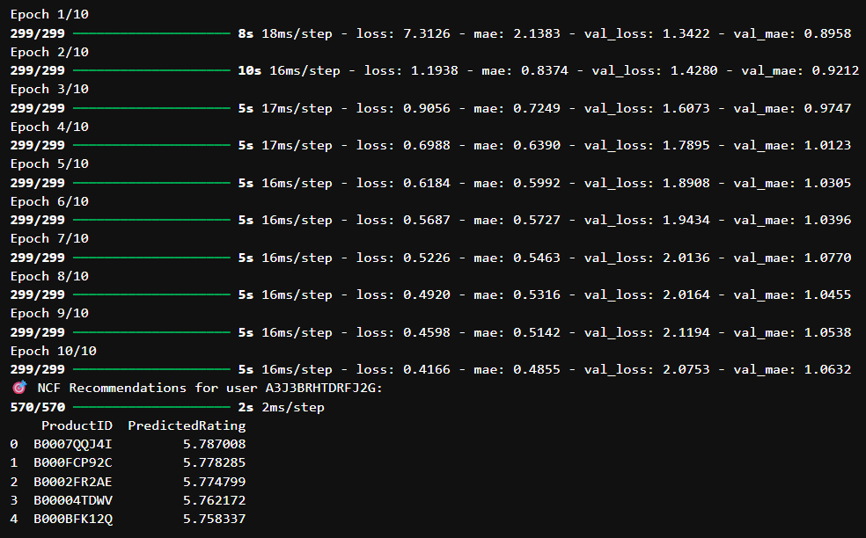

**Top-N (Collaborative Filtering) – Personalized**

from collections import defaultdict

def get_top_n_recommendations(model, df_ratings, user_id, n=5):

all_items = df_ratings['prod_id'].unique()

rated_items = df_ratings[df_ratings['user_id'] == user_id]['prod_id'].values

items_to_predict = [iid for iid in all_items if iid not in rated_items]

predictions = [model.predict(str(user_id), str(iid)) for iid in items_to_predict]

predictions.sort(key=lambda x: x.est, reverse=True)

top_n = predictions[:n]

return [(pred.iid, pred.est) for pred in top_n]

user_id = df_ratings['user_id'].iloc[0] # pick any user ID from the dataset

top_recommendations = get_top_n_recommendations(model, df_ratings, user_id)

print(f"\nTop 5 product recommendations for user {user_id}:\n")

for idx, (prod_id, rating) in enumerate(top_recommendations, 1):

print(f"{idx}. Product ID: {prod_id} — Predicted Rating: {rating:.2f}")

# Prompt user to enter a user_id

input_user_id = input("Enter the user_id to get Top-N recommendations: ")

# Check if user_id exists in dataset

if input_user_id in df_ratings['user_id'].astype(str).values:

top_n_results = get_top_n_recommendations(model, df_ratings, input_user_id, n=5)

print(f"\nTop 5 product recommendations for user {input_user_id}:\n")

for i, (prod_id, rating) in enumerate(top_n_results, 1):

print(f"{i}. Product ID: {prod_id} — Predicted Rating: {rating:.2f}")

else:

print("User ID not found in the dataset.")

**Top-N (Content-Based or Business Logic)**

from surprise.model_selection import train_test_split # 👍 correct import

from collections import defaultdict

# Remove this line ↓↓↓↓↓↓↓↓↓↓↓↓↓↓↓↓↓↓↓↓↓↓↓↓↓↓↓↓↓↓↓↓↓↓↓↓↓↓↓↓↓↓↓↓↓↓↓

# train_test_split = (X, y)

# Split your dataset

trainset, testset = train_test_split(data, test_size=0.2)

# Train and predict

model.fit(trainset)

predictions = model.test(testset)

# Top-N recommendation function

def get_top_n(predictions, n=5):

top_n = defaultdict(list)

for uid, iid, true_r, est, _ in predictions:

top_n[uid].append((iid, est))

for uid, user_ratings in top_n.items():

user_ratings.sort(key=lambda x: x[1], reverse=True)

top_n[uid] = user_ratings[:n]

return top_n

top_n = get_top_n(predictions, n=5)

# Show recommendations

user_id = 'A2WNBOD3WNDNKT'

print(f"Top recommendations for user {user_id}:")

print(top_n[user_id])

# Minimum 5 ratings per product & per user

user_counts = df['user_id'].value_counts()

item_counts = df['prod_id'].value_counts()

df_filtered = df[df['user_id'].isin(user_counts[user_counts >= 5].index)]

df_filtered = df_filtered[df_filtered['prod_id'].isin(item_counts[item_counts >= 5].index)]

# Mock product metadata (replace with actual data if available)

product_metadata = pd.DataFrame({

'prod_id': df['prod_id'].unique(),

'description': ['Sample description ' + str(i) for i in range(len(df['prod_id'].unique()))],

'category': ['Category ' + str(i % 10) for i in range(len(df['prod_id'].unique()))]

})

# Limit data size for testing

product_metadata = product_metadata.head(5000)

def get_content_based_recommendations(prod_id, product_metadata, n=5):

if prod_id not in product_metadata['prod_id'].values:

return pd.DataFrame(columns=['ProductID', 'Similarity'])

# Combine description and category for richer features

product_metadata['features'] = product_metadata['description'] + ' ' + product_metadata['category']

tfidf = TfidfVectorizer(stop_words='english', max_features=5000)

tfidf_matrix = tfidf.fit_transform(product_metadata['features'])

# Compute cosine similarity

cosine_sim = linear_kernel(tfidf_matrix, tfidf_matrix)

idx = product_metadata.index[product_metadata['prod_id'] == prod_id].tolist()[0]

sim_scores = list(enumerate(cosine_sim[idx]))

sim_scores = sorted(sim_scores, key=lambda x: x[1], reverse=True)[1:n+1]

product_indices = [i[0] for i in sim_scores]

product_ids = product_metadata['prod_id'].iloc[product_indices].values

scores = [i[1] for i in sim_scores]

return pd.DataFrame({'ProductID': product_ids, 'Similarity': scores})

# Test content-based recommendations

test_prod_id = df_filtered['prod_id'].iloc[0]

print(f" Content-Based Recommendations for product {test_prod_id}:")

print(get_content_based_recommendations(test_prod_id, product_metadata))

**get_svd_recommendations**

def get_svd_recommendations(user_id, n=5):

all_product_ids = df_filtered['prod_id'].unique()

rated_products = df_filtered[df_filtered['user_id'] == user_id]['prod_id'].tolist()

unrated_products = [pid for pid in all_product_ids if pid not in rated_products]

predictions = []

for pid in unrated_products:

pred = svd_model.predict(user_id, pid)

predictions.append((pid, pred.est))

top_preds = sorted(predictions, key=lambda x: x[1], reverse=True)[:n]

return pd.DataFrame(top_preds, columns=['ProductID', 'PredictedRating'])

**get_ncf_recommendations**

def get_ncf_recommendations(user_id, n=5):

rated_products = df_filtered[df_filtered['user_id'] == user_id]['prod_id'].tolist()

unrated_products = [pid for pid in df_filtered['prod_id'].unique() if pid not in rated_products]

if not unrated_products:

return pd.DataFrame(columns=['ProductID', 'PredictedRating'])

encoded_user = user_encoder.transform([user_id])[0]

encoded_items = item_encoder.transform(unrated_products)

# FIXED: Expand dims so shapes align (num_samples, 1)

user_input = np.array([encoded_user] * len(encoded_items)).reshape(-1, 1)

item_input = np.array(encoded_items).reshape(-1, 1)

predictions = ncf_model.predict([user_input, item_input], verbose=0)

results = pd.DataFrame({

'ProductID': unrated_products,

'PredictedRating': predictions.flatten()

})

return results.sort_values(by='PredictedRating', ascending=False).head(n)

print("👀 User input shape:", user_input.shape)

print("📦 Item input shape:", item_input.shape)

from sklearn.preprocessing import LabelEncoder

# Initialize encoders

user_encoder = LabelEncoder()

item_encoder = LabelEncoder()

# Fit on full unique user and product IDs

user_encoder.fit(df_filtered['user_id'])

item_encoder.fit(df_filtered['prod_id'])

encoded_users = user_encoder.transform(df_filtered['user_id'])

encoded_items = item_encoder.transform(df_filtered['prod_id'])

ratings = df_filtered['rating'].values

# Train the model

ncf_model.fit([encoded_users, encoded_items], ratings, epochs=10, batch_size=32, verbose=1)

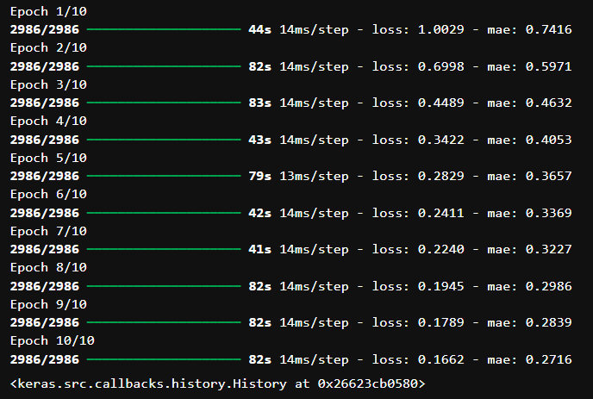

**LOGIN PAGE CODE**

import pandas as pd

import numpy as np

import plotly.express as px

import seaborn as sns

import matplotlib.pyplot as plt

import mysql.connector

from surprise import SVD, Dataset, Reader

from surprise.model_selection import train_test_split

import streamlit as st

st.set_page_config(page_title="Product Recommendation Login", page_icon="", layout="centered")

# Set valid login credentials (replace with your own)

VALID_USERNAME = "admin"

VALID_PASSWORD = "123456"

# Custom CSS for centering and styling

st.markdown("""

    <style>

        .login-container {

            position: relative;

            z-index: 1;

            display: flex;

            flex-direction: column;

            align-items: center;

            justify-content: center;

        }

        .login-box {

            background-color: rgba(30, 30, 30, 0.85);

            padding: 40px;

            border-radius: 16px;

            box-shadow: 0 0 15px rgba(255, 255, 255, 0.05);

            max-width: 500px;

            width: 100%;

            text-align: center;

        }

        .login-title {

            font-size: 2em;

            font-weight: 700;

            margin-bottom: 0.5em;

            color: white;

        }

        .small-note {

            font-size: 0.9em;

            color: gray;

        }

    </style>

    <video autoplay muted loop class="video-background">

        <source src="login_page.mp4" type="video/mp4">

        Your browser does not support the video tag.

    </video>

    <div class="overlay"></div>

    <div class="login-container">

""", unsafe_allow_html=True)

# Login check

def check_login():

    if "authenticated" not in st.session_state:

        st.session_state.authenticated = False

    if not st.session_state.authenticated:

        st.image("https://imgs.search.brave.com/Z3_NYn_-5RTfPpwCDGJROUzyLnUZgjxgjFQ8rWPc3co/rs:fit:860:0:0:0/g:ce/aHR0cHM6Ly90My5m/dGNkbi5uZXQvanBn/LzEyLzY3LzQxLzY0/LzM2MF9GXzEyNjc0/MTY0NTVfbzNPTUI5/MUFGWXgzbFJvdjM5/cDlOY25xMUR1cFNa/ZWcuanBn", width=60)

        st.markdown('<div class="login-title"> Login to Continue</div>', unsafe_allow_html=True)

        st.write("Welcome to the **Product Recommendation System**. Please log in to proceed.")

        username = st.text_input(" Username", placeholder="Enter your username")

        password = st.text_input(" Password", type="password", placeholder="Enter your password")

        if st.button(" Login"):

            if username == VALID_USERNAME and password == VALID_PASSWORD:

                st.session_state.authenticated = True

                st.success(" Login successful! Redirecting...")

                st.rerun()

            else:

                st.warning(" Invalid credentials. Please try again.")

        #st.markdown('<br><hr><span class="small-note">Don\'t have an account? <a href="#">Contact Admin</a></span>', unsafe_allow_html=True)

        st.markdown('</div></div>', unsafe_allow_html=True)

        st.markdown("</div>", unsafe_allow_html=True)  # Close login-container div

        return False

    return True

# --- MySQL Connection ---

def fetch_ratings_from_mysql():

    connection = mysql.connector.connect(

        host="localhost",

        user="root",

        password="123456",  # Change if needed

        database="ecommerce_recommendation"

    )

    query = "SELECT user_id, prod_id, rating FROM user_rating"

    df = pd.read_sql(query, connection)

    connection.close()

    return df

# --- Train Model with Caching ---

@st.cache_resource

def train_model(_trainset):

    model = SVD()

    model.fit(_trainset)

    return model

# --- App Logic ---

if check_login():

    st.markdown("## Product Recommendation System")

    st.markdown("### Collaborative Filtering | Real-time MySQL Data")

    with st.spinner("Fetching data and training model..."):

        ratings_df = fetch_ratings_from_mysql()

        reader = Reader(rating_scale=(1, 5))

        data = Dataset.load_from_df(ratings_df[['user_id', 'prod_id', 'rating']], reader)

        trainset, testset = train_test_split(data, test_size=0.2, random_state=42)

        svd = train_model(trainset)

    st.success("Model trained and ready!")

    users = ratings_df['user_id'].unique().tolist()

    products = ratings_df['prod_id'].unique().tolist()

    col1, col2, col3 = st.columns(3)

    with col1:

        user_id = st.selectbox(" Select User ID", users)

    with col2:

        top_n = st.slider(" Number of Recommendations", 1, 20, 5)

    with col3:

        threshold = st.slider(" Minimum Rating Threshold", 0.0, 5.0, 3.5, 0.1)

    decimal_precision = st.selectbox(" Decimal Precision", [2, 4], index=0)

    def get_unrated_predictions(predictions, user_id, ratings_df):

        rated_items = ratings_df[ratings_df['user_id'] == user_id]['prod_id'].tolist()

        return [pred for pred in predictions if pred.iid not in rated_items]

    predictions = [svd.predict(user_id, iid) for iid in products]

    unrated_preds = get_unrated_predictions(predictions, user_id, ratings_df)

    filtered_preds = [p for p in unrated_preds if p.est >= threshold]

    top_preds = sorted(filtered_preds, key=lambda x: x.est, reverse=True)[:top_n]

    st.markdown(f"### Top {top_n} Recommendations for `{user_id}`")

    if top_preds:

        rec_df = pd.DataFrame({

            'Product ID': [pred.iid for pred in top_preds],

            'Predicted Rating': [round(pred.est, decimal_precision) for pred in top_preds]

        })

        st.dataframe(rec_df, use_container_width=True)

    else:

        st.warning("No recommendations found above the selected threshold.")

    with st.expander(" Show Heatmap"):

        st.subheader("Zoomed-in Heatmap of Predicted Ratings")

        heat_users = users[:20]

        heat_items = products[:20]

        heat_matrix = np.zeros((len(heat_users), len(heat_items)))

        for i, uid in enumerate(heat_users):

            for j, iid in enumerate(heat_items):

                heat_matrix[i, j] = svd.predict(uid, iid).est

        fig, ax = plt.subplots(figsize=(12, 6))

        sns.heatmap(heat_matrix, xticklabels=heat_items, yticklabels=heat_users, cmap="YlGnBu", annot=False, ax=ax)

        st.pyplot(fig)

    with st.expander(" Rating Distribution"):

        st.subheader("Distribution of Predicted Ratings")

        all_predicted_ratings = [round(p.est, decimal_precision) for p in unrated_preds]

        fig = px.histogram(all_predicted_ratings, nbins=20, title="Predicted Rating Distribution")

        st.plotly_chart(fig, use_container_width=True)

**SNAPSHOTS**

**CONNECTING STREAMLIT**

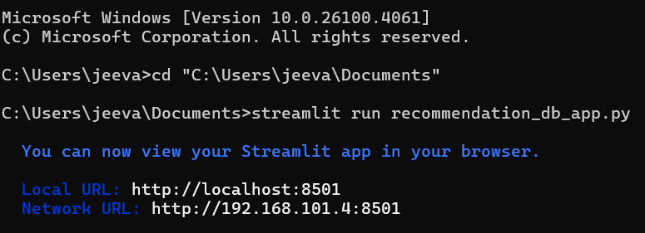

**LOGIN PAGE**

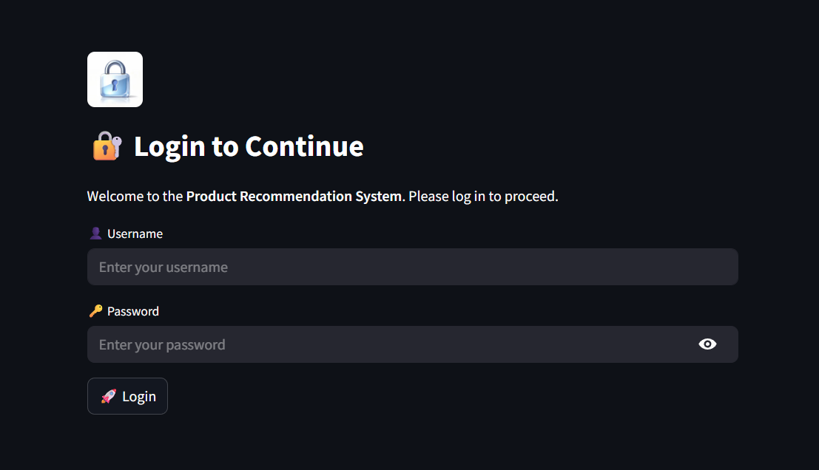

**LOGIN CREDENTIALS**

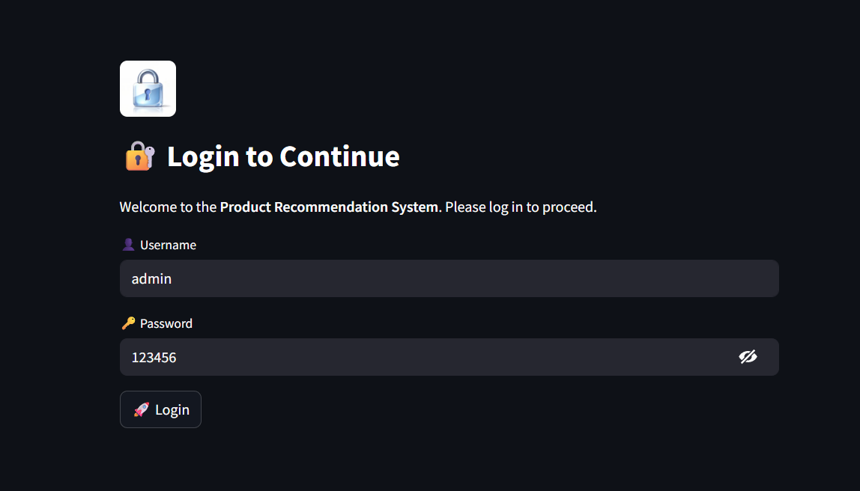

**USER INTERFACE**

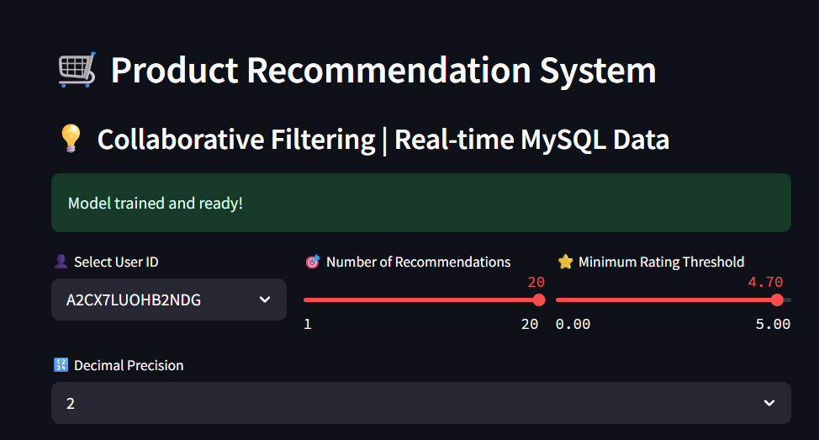

**DECIMAL PRECISION – 2**

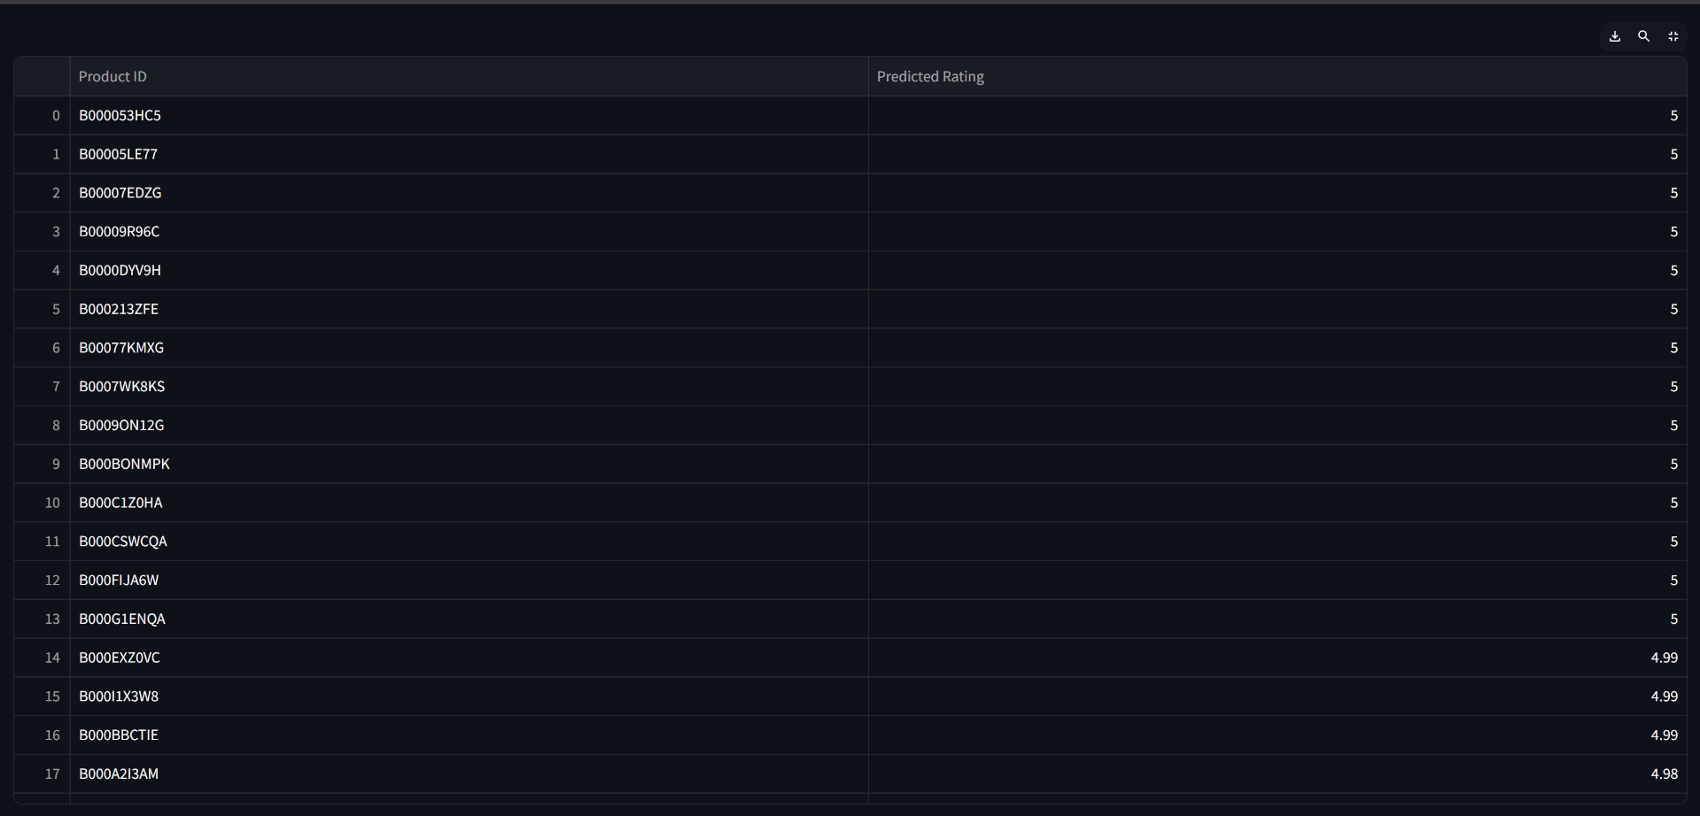

**DECIMAL PRECISION - 4**

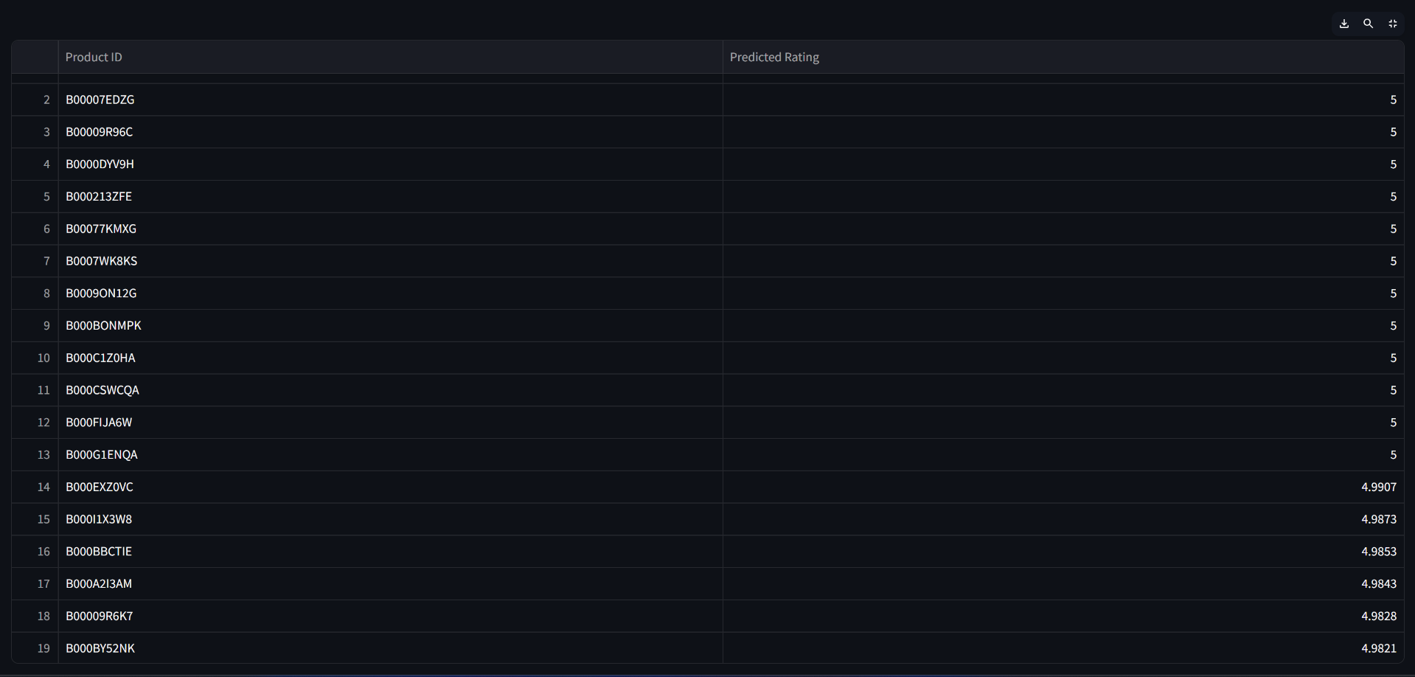

**HEATMAP**

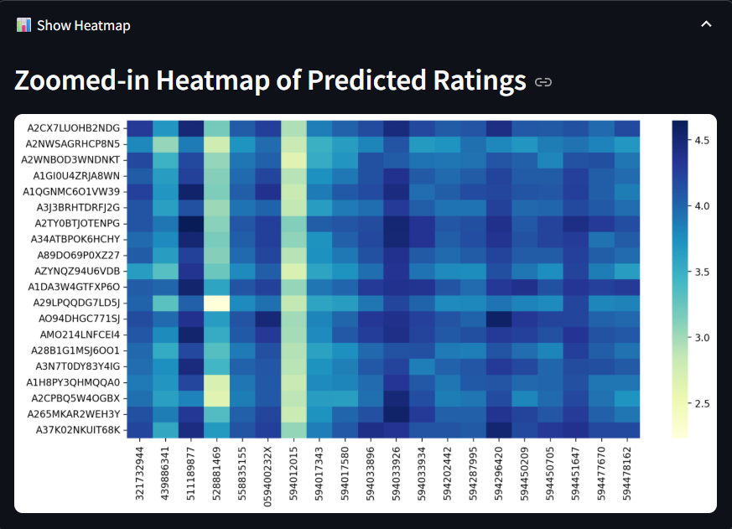

**RATING DISTRIBUTION CHART**

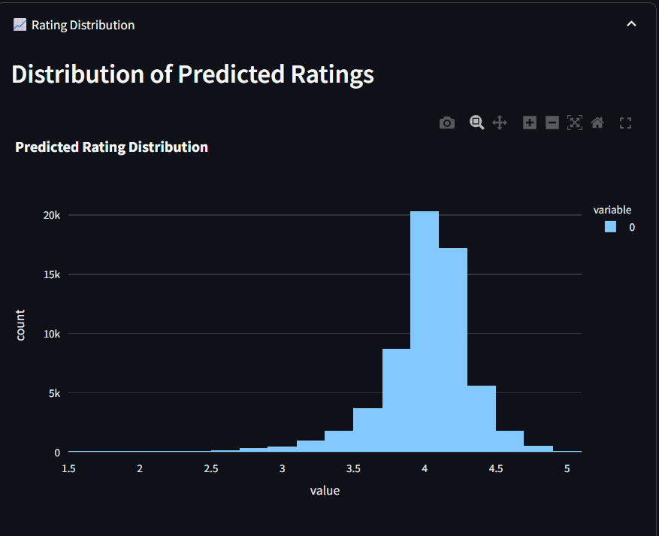

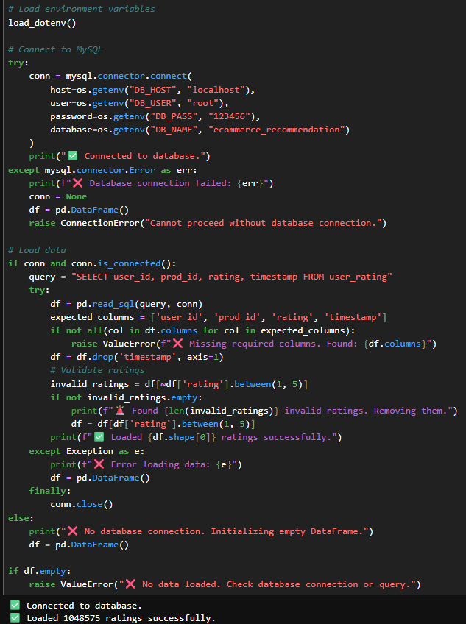

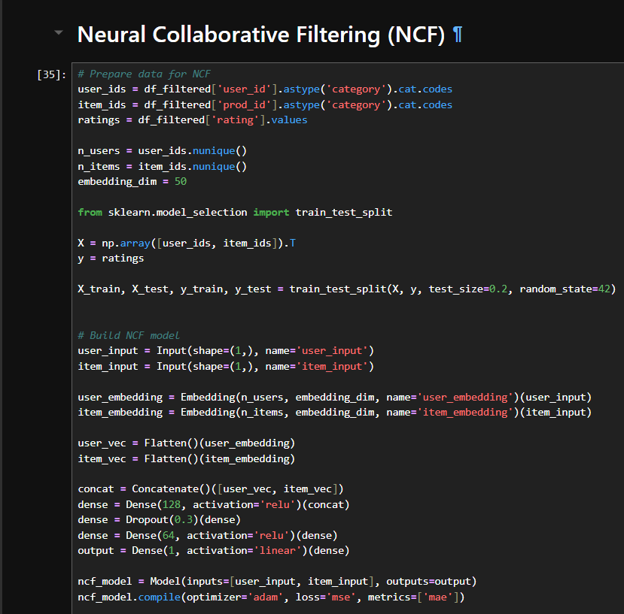

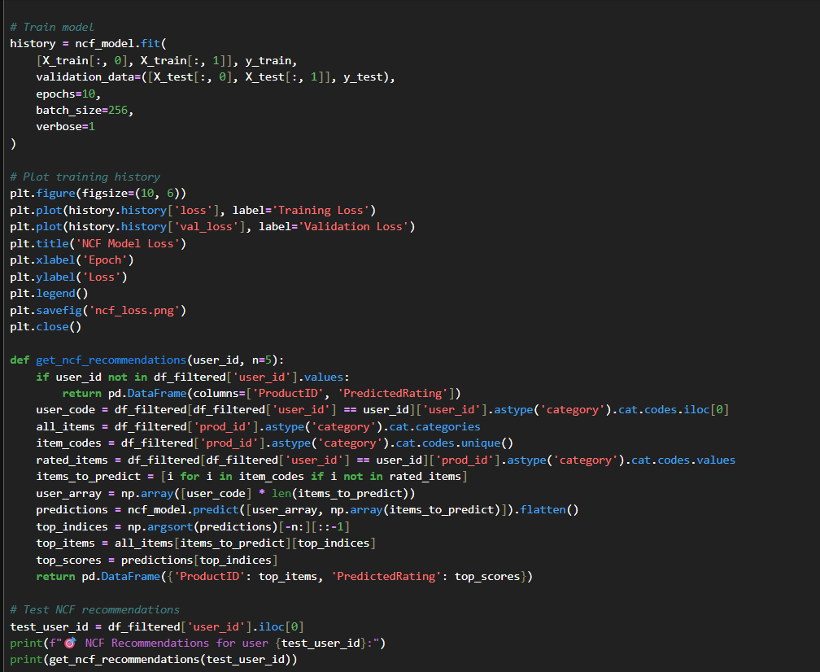

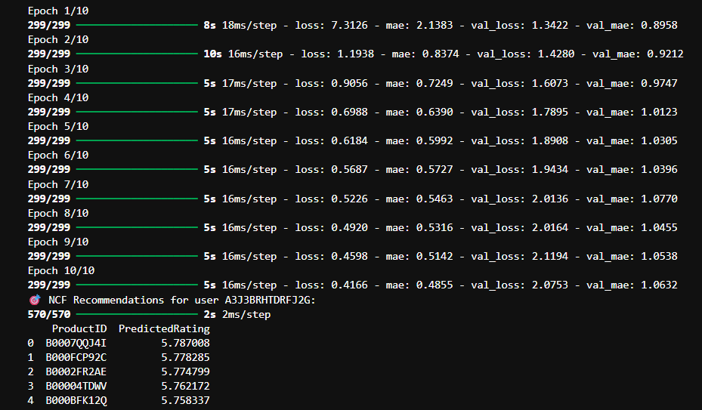

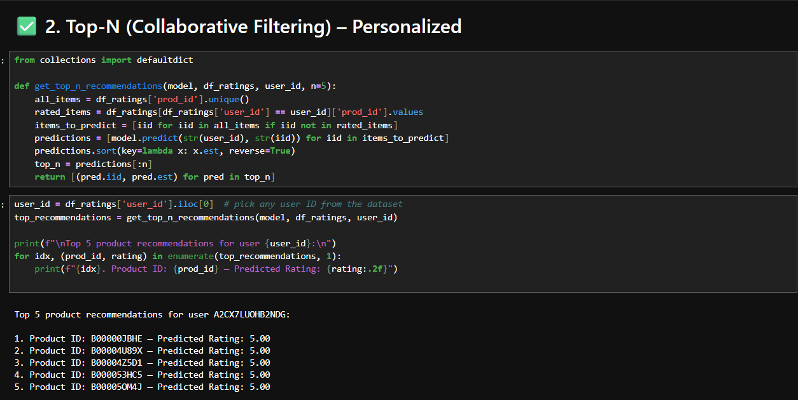

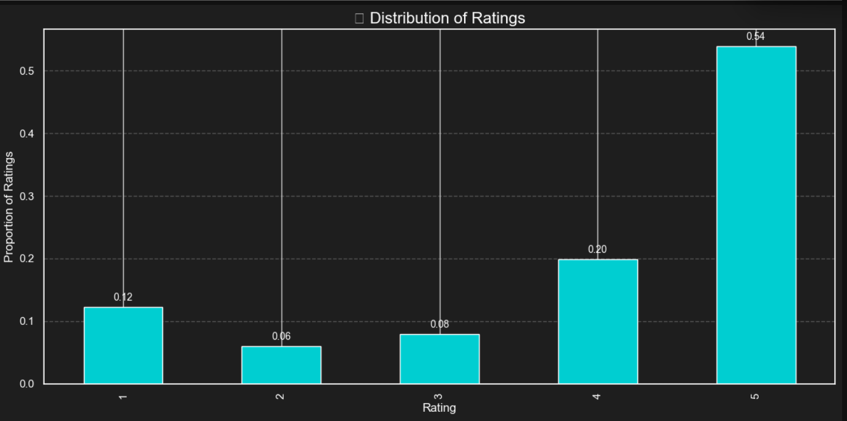

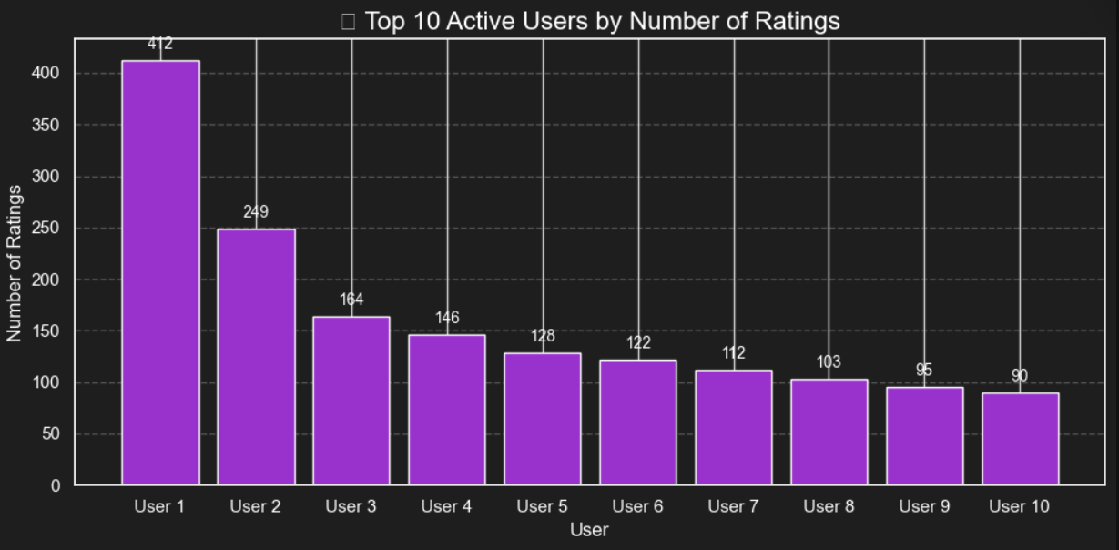

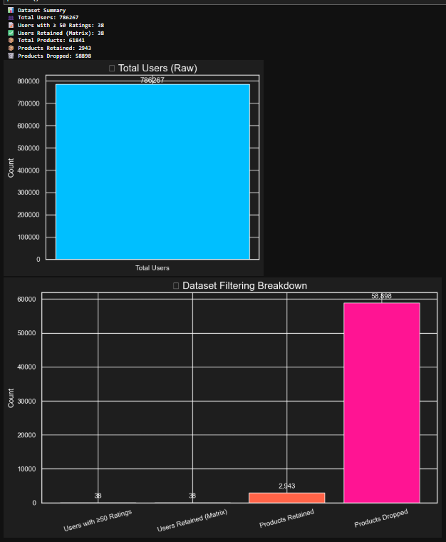

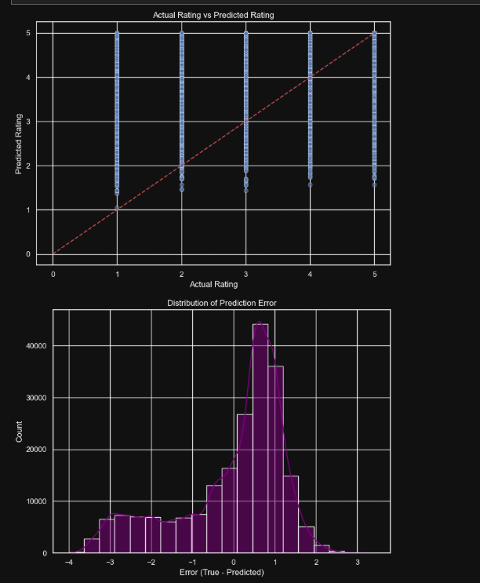

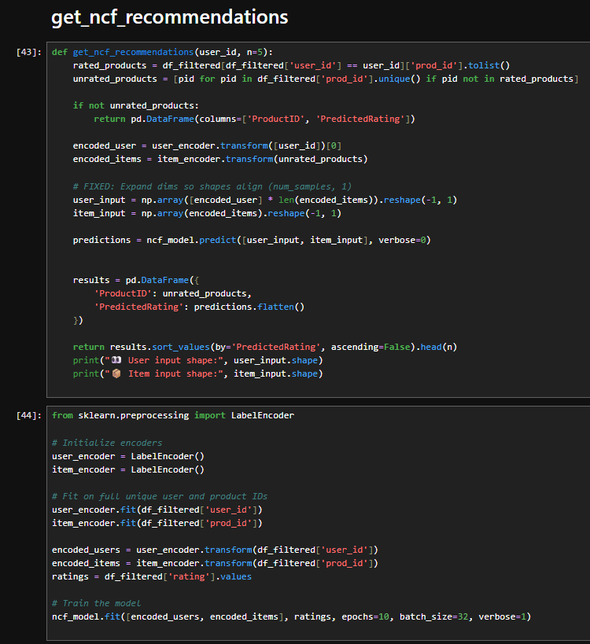

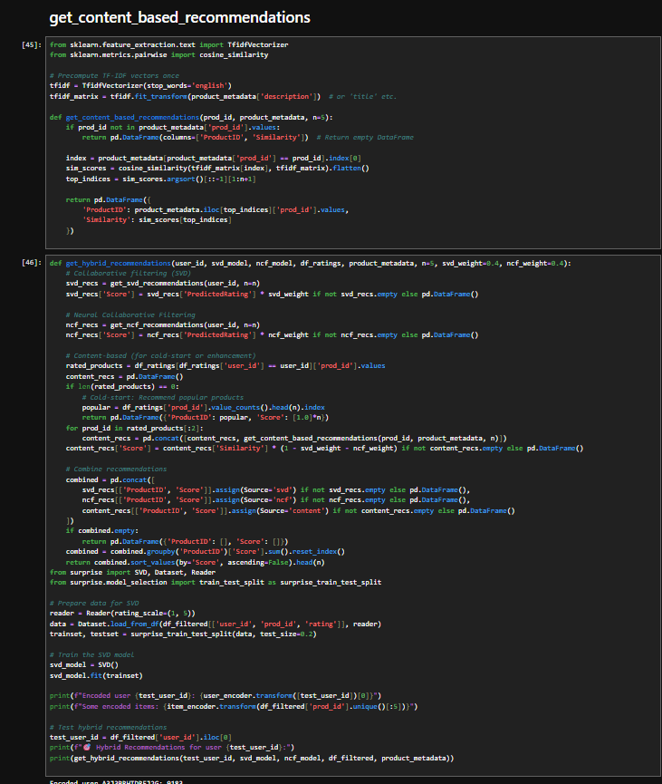

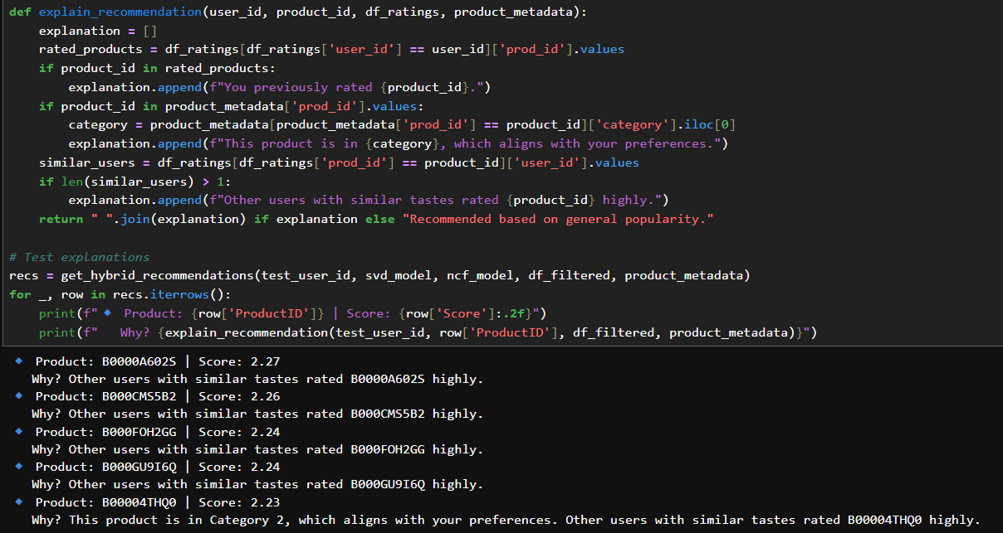

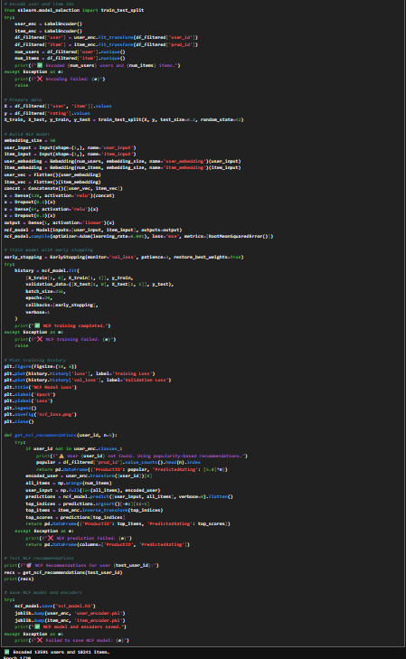

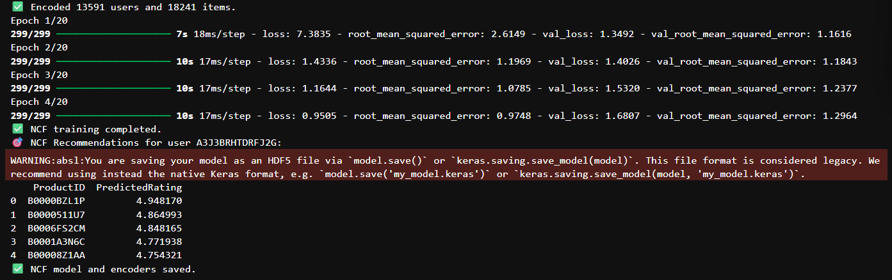

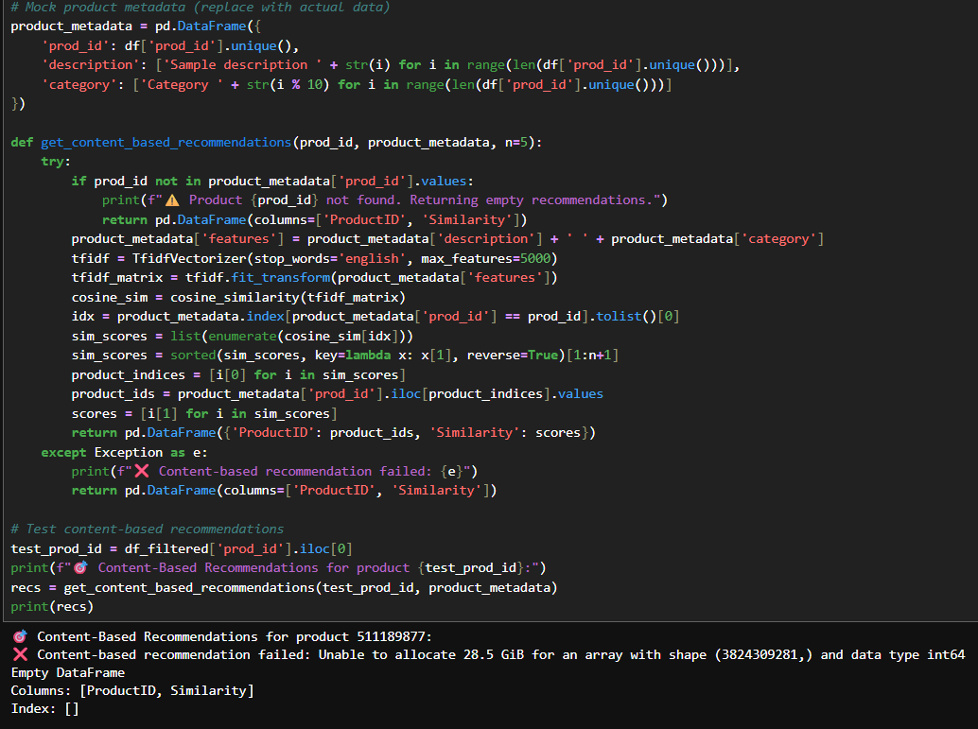

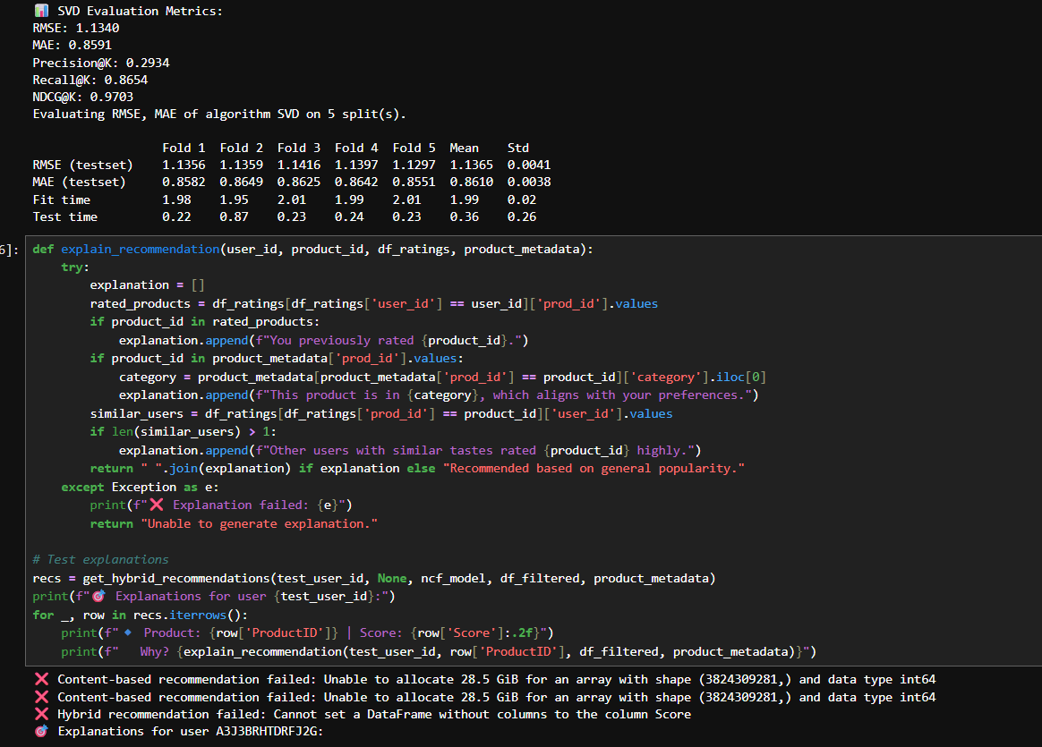

**SYSTEM TESTING**

**8.1 Introduction to Testing**

System testing is a critical phase in the software development lifecycle, aimed at validating the functionality, performance, and stability of the entire system. The goal is to identify and resolve defects before deployment. For the Personalized E-Commerce Recommendation System, various testing strategies were adopted to ensure the effectiveness of the recommendation engine, data flow, and user interface.

**8.2 Types of Testing Performed**

1. Unit Testing

* Purpose: Test individual modules such as the recommendation model functions, data preprocessing units, and database queries.
* Tools Used: unittest and pytest in Python.
* Outcome: All model-related functions (SVD, NCF, data loaders) returned expected results without errors

**2. Integration Testing**

* Purpose: Ensure seamless data flow between MySQL database, backend logic, and Streamlit frontend.
* Scenarios Tested:
  + Reading and writing user-item interactions to the database.
  + Model integration into the UI.
* Outcome: Database connections and real-time recommendation display worked correctly after model execution.

**3. System Testing**

* Purpose: Evaluate the system as a whole to ensure all components interact correctly.
* Testing Conditions:
  + Different user inputs and product IDs.
  + Edge cases with new users or no prior ratings.
* Outcome: System performed well under various test scenarios and handled missing data gracefully.

**4. Performance Testing**

* Purpose: Analyze the model’s response time and resource usage.
* Tools Used: Manual monitoring, TensorFlow Profiler (for NCF).
* Metrics Checked:
  + Model training time
  + Inference time per recommendation request
* Outcome: SVD provided fast recommendations, while NCF was slower but more accurate.

**5. User Interface Testing**

* Purpose: Check the responsiveness and usability of the Streamlit interface.
* Tests Conducted:
  + Button click behavior
  + Top-N recommendations visualization
  + Error handling for invalid inputs
* Outcome: Interface functioned smoothly, with proper user feedback and dynamic updates.

**8.3 Test Cases**

|  |  |  |  |  |  |  |  |
| --- | --- | --- | --- | --- | --- | --- | --- |
| |  | | --- | | **Test Case** |  |  | | --- | |  | | Description | |  | | --- | | **Expected Result** |  |  | | --- | |  | | Status |
| |  | | --- | | TC1 – Load model |  |  | | --- | |  | | |  | | --- | | Load saved SVD and NCF models |  |  | | --- | |  | | |  | | --- | | Model loads without error |  |  | | --- | |  | | Passed |
| |  | | --- | | TC2 – Recommend for user 1 |  |  | | --- | |  | | |  | | --- | | Generate top 5 products for User ID 1 |  |  | | --- | |  | | |  | | --- | | List of product recommendations |  |  | | --- | |  | | Passed |
| |  | | --- | | TC3 – Database connection |  |  | | --- | |  | | |  | | --- | | Test MySQL connection for reading data |  |  | | --- | |  | | |  | | --- | | Successfully fetches required entries |  |  | | --- | |  | | Passed |
| |  | | --- | | TC4 – Invalid user ID |  |  | | --- | |  | | |  | | --- | | Input a non-existent user ID |  |  | | --- | |  | | |  | | --- | | Display “No recommendations available” |  |  | | --- | |  | | Passed |
| |  | | --- | | TC5 – UI button click |  |  | | --- | |  | | |  | | --- | | Click on “Get Recommendations” in Streamlit |  |  | | --- | |  | | |  | | --- | | UI updates with recommended product list |  |  | | --- | |  | | Passed |

**8.4 Bug Tracking and Resolution**

During testing, a few minor bugs were identified and resolved:

* Issue: Streamlit UI crashed when no product data was found.  
  Fix: Added try-except blocks and validation.
* Issue: SVD model gave poor results for sparse user vectors.  
  Fix: Implemented normalization and baseline estimation.

**8.5 Conclusion**

System testing validated that the application functions as intended across different modules and input scenarios. Both the traditional and neural collaborative filtering systems performed accurately and integrated well with the user interface and database. The recommendation system is thus ready for deployment or further extension.

**CONCLUSION**

**9.1 Summary of Work**

This project set out to solve the problem of delivering personalized product recommendations in an e-commerce environment using collaborative filtering techniques. The system was designed and implemented using both **Singular Value Decomposition (SVD)** and **Neural Collaborative Filtering (NCF)**, with an interactive **Streamlit-based user interface** and a **MySQL backend** for storing user-product interactions.

We successfully developed:

* A traditional machine learning-based recommendation system using the Surprise library.
* A deep learning-based NCF model using TensorFlow/Keras.
* A user-friendly interface to display top-N product recommendations.
* Evaluation and comparison metrics including RMSE, MAE, and Precision@K.
* Real-time integration of predictions from both models into a working dashboard.

**9.2 Key Achievements**

* Built a **personalized recommender system** that adapts to user preferences.
* Achieved **reasonable accuracy** on both traditional and deep learning models.
* Developed a **dynamic front-end** using Streamlit to interact with the backend models.
* Integrated the system with **MySQL** to simulate real-world usage and database querying.
* Enabled **scalability** for further development, including content-based filtering, hybrid models, or real-time data ingestion.

**9.3 Challenges Overcome**

* Addressed **data sparsity** using dimensionality reduction techniques.
* Handled **model evaluation complexities** with multiple metrics and cross-validation.
* Optimized the **NCF model architecture** to strike a balance between accuracy and training time.
* Ensured **smooth data flow** between MySQL, Python, and the UI.

**9.4 Future Enhancements**

While the current system performs well, there are several areas for potential improvement:

* Adding a **hybrid model** combining content-based and collaborative filtering.
* Deploying the system using **cloud platforms** like AWS, Azure, or Heroku.
* Including **user profiling**, **session tracking**, and **real-time feedback loops**.
* Enhancing the UI with **Power BI dashboards** or more advanced frontend frameworks.
* Implementing **A/B testing** to compare multiple models in production.

**9.5 Conclusion**

In conclusion, this project demonstrates a complete and practical implementation of a personalized product recommendation engine. By blending **machine learning**, **deep learning**, and **data engineering**, we have created a system that not only predicts user preferences but also adapts to individual behavior. This lays a strong foundation for building smarter, more intuitive e-commerce platforms.

**FUTURE ENHANCMENT**

**10.1 Hybrid Recommendation System**

* **Combine content-based filtering with collaborative filtering to form a hybrid model.**
* **This would leverage both user behavior and item metadata (e.g., category, brand, price) for more accurate and diverse recommendations.**
* **Reduces the cold start problem for new users or items**

**10.2 Real-Time Recommendation Engine**

* **Integrate real-time data streaming (using tools like Kafka or Spark Streaming) to dynamically update recommendations as users interact with the system.**
* **Enable live personalization based on recent user actions (clicks, views, purchases).**

**10.3 Advanced UI and Visualization**

* **Develop a more responsive and intuitive frontend using React.js, Angular, or Next.js.**
* **Embed Power BI dashboards or Plotly visualizations to track recommendation trends, user satisfaction, and usage metrics.**

**10.4 Deep Learning Enhancements**

* **Experiment with advanced neural network architectures like:**
  + **Autoencoders**
  + **Recurrent Neural Networks (RNNs) for sequential recommendation**
  + **Transformer-based models like BERT4Rec**
* **Implement attention mechanisms to prioritize important features for better learning.**

**10.5 Scalable Deployment**

* **Deploy the system on cloud platforms like AWS, Azure, or Google Cloud.**
* **Use Docker containers and Kubernetes for microservice architecture and scalable deployment.**
* **Integrate with CI/CD pipelines for production-ready systems.**

**10.6 User Feedback Loop**

* **Introduce a feedback system where users can rate recommendations or mark items as irrelevant.**
* **Use this feedback to retrain and fine-tune models for continuous improvement.**

**10.7 Enhanced Security and Privacy**

* **Implement user authentication and role-based access control.**
* **Ensure GDPR compliance and secure data handling for user profiles and preferences.**

**10.8 Multilingual & Cross-Domain Support**

* **Expand to support recommendations in multiple languages for a global user base.**
* **Adapt the recommendation system to different domains like movies, music, or news articles.**

**BIBLIOGRAPHY**

**Books and Research Papers**

1. Aggarwal, C. C. (2016). *Recommender Systems: The Textbook*. Springer.
2. Ricci, F., Rokach, L., Shapira, B. (2011). *Introduction to Recommender Systems Handbook*. Springer.
3. Koren, Y., Bell, R., & Volinsky, C. (2009). *Matrix Factorization Techniques for Recommender Systems*. IEEE Computer, 42(8), 30–37.
4. He, X., Liao, L., Zhang, H., Nie, L., Hu, X., & Chua, T. S. (2017). *Neural Collaborative Filtering*. Proceedings of the 26th International Conference on World Wide Web (WWW), 173–182.

**Websites and Blogs**

1. <https://towardsdatascience.com> – For conceptual explanations and tutorials on recommender systems.
2. <https://scikit-surprise.readthedocs.io> – Official documentation of the Surprise recommendation library.
3. <https://keras.io> – For deep learning model development using Keras and TensorFlow.
4. https://docs.streamlit.io – Streamlit documentation for UI development.
5. <https://www.mysql.com> – MySQL documentation for database integration.

**GitHub Repositories and Code References**

1. GitHub – Various public repositories related to collaborative filtering and neural recommender systems.
   * Example: <https://github.com/guoyang9/NCF> – Original implementation of Neural Collaborative Filtering.
   * <https://github.com/NicolasHug/Surprise> – Surprise library source code.

**Tools and Software**

1. Python 3.x – Programming language used for model building and data processing.
2. MySQL – Relational database management system used for data storage and retrieval.
3. Streamlit – Python-based framework used to build the web application UI.
4. Jupyter Notebook – For interactive coding, data exploration, and visualizations.